Moba Technical design doc

Table of Contents

Project Pitch 4

Overview 4

Evaluation 4

Engine of Choice 5

Target Platform 5

Development Requirements 5

Online Services 7

Networking 7

Servers 8

Databases 8

Cloud Services 8

Development Plan 8

Project Objectives 10

Finished Product Goals 11

Full Online Launch 12

More Levels 12

Sequel 12

Project Structure 12

Project structure and naming File formats naming convention 12

General Naming Rules 13

Gamemodes 14

Classic 5v5 14

2D Layout 15

Brawl 15

2D Layout 15

Levels Parameters and metrics 15

3v3 15

2D Layout 15

Levels Parameters and metrics 15

Asset List 16

3D Assets 16

Audio Asset List 19

UI 2D Art 19

Coding Conventions 20

Coding Naming Conventions 20

General Coding Rules 20

Guidelines 21

Const Correctness 21

The 'auto' Keyword (Please Try to Avoid) 22

Lambdas and Anonymous Functions (Lets Keep it simple) 22

Strongly - Typed Enums 22

Code Formatting 22

Switch Statements 23

Namespaces: Do we really need those? 24

General Style 24

Project Technical Details and explanations 24

Features 24

Chest Opening/Lootboxes and Ad boxes 25

Minigames in the Loading Screen 30

Login 31

Spin for rewards 32

Match data 35

Match History 36

Inventory 37

Tutorials 38

General Reference Table of Metrics 39

Mechanics 39

Movement 39

Audio 42

Aiming 44

Spawning 46

Interaction 48

Target Lock-on 48

Abilities – Cooldown as well 49

GameManager 52

Animations 53

UI 54

Ability Indicators 54

Attacking and Targeting (This includes turret and monsters) 56

Camera – Locking and Unlocking 57

Health 57

Levelling up and Exp 58

Stats tracking 59

Battle spells 60

Stretch Goals 61

Other Mechanics 62

Account 62

Localization 63

Caps 63

Settings 65

Effects 65

States 66

Death Respawn Time 67

Damage taken 68

Menu Navigation 69

Experience and Levelling system 69

In-Match Inventory and shop system 69

In-Match UI 71

Monsters 72

Hero stuff 72

In-House Tools 81

Characters 82

Technical Diagrams (UML) 82

Class Diagrams 82

A.I. Horde System Behaviour Tree 82

UI/UX 84

Flow Charts/ State Diagram 84

Wireframes/Mockups 84

Test Plan 85

Types of tests 85

Test Cadence 86

Test Schedule 86

Technical Risks 87

# Goals

## Bafta

* Release Date: The game must have been released within the eligibility period specified by BAFTA. Typically, the eligibility period covers a specific calendar year.
  + The eligibility period specified by BAFTA for mobile games for the 2024 BAFTA Games Awards is games released between December 10, 2022, and November 24, 2023. Developers and publishers can submit their games released within this period for consideration. The deadline for nominations is November 9, 2023. A longlist of contenders will be revealed on December 14, 2023. The winners of the BAFTA Games Awards 2024 will be announced in Spring 2024 at the prestigious BAFTA Games Awards event
* UK Release: The game should have been commercially released in the United Kingdom during the eligibility period. However, note that there are certain categories that may have different requirements, such as international awards or awards for specific regions.
* Genre: BAFTA has specific categories for mobile games, such as "Mobile Game," "Portable Game," or "Game on Mobile." Ensure that your game fits within these categories.
* Excellence and Innovation: The game should demonstrate excellence and innovation in terms of gameplay, design, storytelling, visuals, audio, user experience, or other aspects. It should push the boundaries of mobile gaming or deliver a unique and engaging experience.
  + Ensure that the game runs smoothly, has minimal bugs, and delivers a polished experience.
    - To do this use the profiler
    - make all the UI one screen
    - Use async for loading screen
    - Transitions for every different screen
  + Your game should introduce unique mechanics, strategic elements, or innovative approaches to the MOBA formula that set it apart from existing titles. This could include creative character designs, innovative abilities, or fresh gameplay mechanics.
    - Like overwatch have there be role selection for online or even just for classic match
    - Voting for attack patterns
    - When creating characters look at stories and histories and myths
    - Look at other mobas as they have unique stuff
    - Build your own character gamemode – you use existing passives and skills and each part has a cost and you have a certain amount of points, i.e. I want to buil a tank and I have 30 points altogether and there are 10 tank and I can choose one of their passive but each passive has a cost and this can be done using the factory pattern or the builder pattern
    - First person gamemode
  + MOBA games require careful balance to ensure fair and engaging gameplay. Make sure your game has well-tuned mechanics, balanced character abilities, and strategic depth to provide players with a compelling experience.
    - A point system like in behavioural mathematics book assign each attribute a point then set a level for that attribute
    - Good matchmaking ruleset – look at other games
* Artistic Achievement: The game's art direction, graphics, animation, or visual effects should showcase exceptional artistic qualities that contribute to the overall experience.
  + strive to create visually appealing characters, environments, and animations within your capabilities. A distinctive and well-executed art style can make your game stand out.
    - Fix graphics using profiler
    - Dynamic animation like when they walk near the wall they should put their hand on the wall
    - The world should have lovely vfx and not necessarily th characters but they can affect it
* Gameplay and Mechanics: The game mechanics should be well-crafted, offering enjoyable gameplay and innovative features specific to the mobile platform.
* Player Reception: Positive critical reception and audience feedback are important factors. A game that has received acclaim from players, critics, and industry professionals stands a better chance of being recognized.
  + Focus on creating a game that captivates players and keeps them coming back for more. Consider implementing progression systems, rewards, social features
    - Free clans and nation wars

## Google Play Awards

## Apple Design Awards

## Pocket Gamer Mobile Games Awards

## IMGA (International Mobile Gaming Awards)

## GDC Mobile Game Awards

# Structure for Project

## Speeding Up Iteration Times

Being able to iterate rapidly, not just in code but in art, audio and design is crucial. Do this by making things easier to find.

Using assemblies will really help from a code point of view because they allow us to partition the code, so this means is when we change one of the files in that assembly it only needs to recompile that assembly, which means that on a large project where you might have hundreds or more source files, it makes it go from rather than having to recompile everything, it only has to potentially recompile half a dozen.

Set up things like test level for prototyping and testing

Have debug tools, i.e. on-screen display, developer console to put in cheat commands that lets you make yourself invulnerable etc.

## Designing systems that scale

Something that can scale in terms of being used for an extended time period scale with large amounts of data, large amounts of your things running at a particular point in time.

## Version Control

Branching for major milestones.

Automated Builds (continuous Integration) and automated tests to find problems early on in builds and maintain stability

# Game Name

10 = best names, 1 = worst names

* Heavenly Havoc/Havoc in Heavens -10
* Sacred Uprising - 7
* Blessed Revolt -8/9
* Divine Rebellion - 8
* Faithless Revolution – 7/8
* Holy War: Anarchy's Reckoning - 9
* Freedom Fighters: Conscientious Chaos - 8
* Heresy's Wrath - 6
* Anarchy's Armies - 5
* Divine Insurrection – 6/7
* Conscience in Conflict – 7/8
* Martyrs of Rebellion - 9
* Theocracy's Fall - 9

# Project Pitch

Welcome to Heavenly Havoc, a thrilling co-op 3D mobile MOBA that thrusts you into an unending conflict amidst a world torn apart by religious wars. Choose your side as a freedom fighter, an anti-war activist or a valerian fighting for their beliefs and wield the mystical power of Nazomeita as you join the ranks of the Valorian warriors. Prepare for intense battles where your skills, strategy, and cooperation will determine the fate of a war-torn realm.

## Overview

* **Platform:** Mobile
* **Controls**: Touch screen and joystick controls and button pressing for attacking and button dragging for aiming
* **Players:** 1 player which is multiplayer online where you play in a team
* **Genre:** Multiplayer Online Battle Arena
* **Engine**: Unity 2022.1.4

# Evaluation

|  |  |  |  |
| --- | --- | --- | --- |
| **Aspect** | **Unity** | **Unreal Engine** | **Decision(s)** |
| Documentation | Unity’s documentation is absolutely fantastic. It super clearly fleshed-out with examples and other references. With excellent books that go into detail on various parts of the engine and even post production | Even though UE has a less friendly interface and I have not used it nor made as much documentation on it as much as unity | **Unity** |
| Engine itself | Unity’s is excellent for mobile game and easily ports to most mobile devices with many modifiable changes. Unity provides a friendly-user interface.  Lots of packages need to be added for final products. | C++ and Blueprints provide a great approach to programming for both back and front end when they work together. | **Unity** |
| Level Design | Unity has many things for level design such as pro builder for 3d and more for 2d such as tilemap editor, snaps and etc | It’s still on the works of becoming as good as Unity.  It can be harder to find the exact solution to a problem in comparison to Unity. | **Unity** |
| Organization | Unity is friendly for everyone to use their own way of organizing, therefore it can create messier products if not taken care of from the beginning of development. | *UE is less friendly and makes the user follow the adequate conventions and structures.*  *Blueprints can get out of hand if poorly coded.* | **Unity** |
| Programming | Unity code structure is very messy and allows for inadequate programming and in order to get the same quality/level of programming as unreal is to use many design pattern | Unreal engine comes with specific programming pattern and coding with unreal is naturally decoupled | **Unreal** |
| Time vs Benefit | Unity requires a lot more plugins and code testing, but the benefit is that the porting is easier, the resources available are plenty and solutions and community are also plenty as well. | Built originally for these types of games with in engine feature for much easier development, there’s no competition in this aspect. | **Either** |

## Engine of Choice

**Unity** is the better solution for the development of this MOBA. I have a far greater understanding of unity than any other engine, but I understand more than just the engine as I also have a good grasp on other things such as design patterns and of solution available for some issues that may arise during the development of this game. I am also confident in communicating with the Unity community through message boards, forum and more. I also know how to make use of other available resources to solve certain types of problem affectively.

Another reason as to why Unity is the better solution is its Asset Store, which has a wide variety of plugins that help the development process go much smoother than it would otherwise. I can implement these plugins and find the right solution for the project. Additionally, my deep understanding of Unity's strengths and weaknesses allows me to take the best approach when faced with challenges or problems.

I also have a far more experience with unity than with other engines which makes unity a better solution for building a mobile MOBA. Unity is powerful and flexible and because of this I can effectively create the game mechanics, game features, and other essential components for a MOBA.

//Rewrite in third person

### Target Platform

The platform will not just be restricted to just android and iOS, as there are a large variety of other operating systems such as Huawei’s new operating system that is not android even though it is classified as an android phone, this must be accounted for in order to make the game accessible to as many people as possible and that is why the target platform is all, if not most, mobile devices.

However, the game is not just limited to phones, as other handheld devices are also being targeted such as iPads, tablets and iPods etc. if the devices have the capability to run it. Other examples of target platforms are Windows devices and Blackberry devices and will be able to run on older operating systems.

# Development Requirements

This section describes all needed tools, software and hardware that will be required for the game’s development:

|  |  |
| --- | --- |
| **Aspect** | **Tool/Software** |
| **2D Software** | Photoshop |
|  | Illustrator |
| **3D Software** | Autodesk Maya 2020/Blender |
|  | Substance Painter |
|  | Substance Designer |
|  | ZBrush |
| **Communication** | Discord |
| **Documentation** | Google Docs/ Word Doc |
|  | Wiki Fandom |
|  | Draw.io |
| **Engine** | Unity |
| **Plugins** | Photons |
|  | OneSignal |
|  | Behaviour Bricks |
|  | Animance Lite |
|  | Simple Input |
|  | Cloud Login |
|  | Runtime Utilities |
|  | Universal SDK |
|  | HUD Indicator |
|  | Xsolla |
|  | Relative Layout for Unity |
|  | Gridly |
| **Programming** | Rider |
|  | Behaviour Bricks |
| **Project Management** | Pivotal Tracker |
|  | Trello |
| **SDKs** | Apptutti |
|  | Android Sdk |
|  | UDP |
| **Sound Software** | WWise |
|  | Adobe Audition CC |
| **Source Control** | GitKraken |
|  | GitHub |

|  |  |
| --- | --- |
| **Hardware Aspect** | **Minimum requirements** |
| **Processor** | A mid-range or higher processor is recommended to for playable performance  Octa-core (4x2.3 GHz Mongoose & 4x1.6 GHz Cortex-A53)  Qualcomm Snapdragon 660  Apple A10 |
| **RAM** | The amount of RAM in a device can affect how well a game runs. For a small MOBA, at least 2 GB |
| **Graphics** | A mid-range or better graphics card is recommended.  Mali-T880 MP12  Adreno 512  PowerVR (Series 7XT) GT7600 Plus |
| **Storage** | 64GB |

<https://mtgarena-support.wizards.com/hc/en-us/articles/360054912332-Supported-Mobile-Devices-Minimum-Requirements>

<https://docs.unity3d.com/2020.1/Documentation/Manual/system-requirements.html>

<https://docs.unity3d.com/Manual/system-requirements.html>

# Online Services

## Networking

The Networking in the game will be done by Photon fusion which is a third-party framework that can be used in unity. Photon Unity Networking framework for realtime multiplayer games and applications with no punch through issues.

The client will never be trusted as the game client could be lying. It can always lie, if it says “hey im in this position” that message will need to be validated and verified that they actually can get to that position, if they say I looted this item off of this this corpse, validate and verify it. Can’t send data you don’t want them to see and you can’t ever trust anything from the client.

Have a single source of truth for your player data. E.g. you have multiple zones in your game and players can bounce around between different zone(maps, regions, etc) and the player is stored all in a single database, a single SQL server etc. To do this use some sort of memory cache like a mem cache D or redis and never read and write directly from a database or something like that for you players, instead just read and write directly to that cache and don’t allow your code to do anything other than that. So if your inventory code or item code or whatever is writing stuff don’t allow it to have its own methods, have a single method, a single call for adding an item and a single call for removing and that is it. Don’t have a bunch of them, don’t implement different ways to do it because you will run into issues as it may not cache right.

Exploits and cheats – if you don’t think about exploits and cheats and stuff like that it will destroy your game and because in a multiplayer environment like this especially an MMO a cheater can have a huge impact. Have like an economic tracking when the game gets big enough, so you’re watching how much money is flowing in using hourly report and tagging players.

Networking – build a game and think about the networking while you’re building a game and optimize as you go along. Minimize the network calls and minimize the amount of stuff you’re sending over the network

For fast paced games, the fusion system is highly recommended because it’s one of the fastest networking options available

The architecture will be simple because it is crucial to design a game architecture that is efficient and scalable. Simplifying the architecture helps ensure smooth gameplay and minimizes performance issues, the server must be running, the client working and the netcode and matchmaker system should be robust.

//ref - <https://unity.com/how-to/how-build-design-your-multiplayer-game>

There will also be a focus on latency tolerance as latency can greatly affect the multiplayer experience. Network latencies can vary depending on the distance between and the performance of the networks along the transmission routes. When player are playing with each other, players have to wait for their devices to send and receive information.

Different game types have different requirements for how fast the game progresses, each game has to establish what level of tolerance it has for network latency. Sometimes having synchronization events come in a little slower is okay because you can hide latency with techniques such as prediction and reconciliation.

// ref - <https://unity.com/how-to/multiplayer-game-development-factors>

Multiplayer games are vulnerable to cheating. measures will be Implemented to detect and mitigate cheating, such as server-side validation and secure client-to-server communication.

//ref - <https://docs.unity3d.com/Manual/UNetGettingStarted.html>

Our Main focus should be the gameplay is smoothly performed on both the client and server sides so building replicable components is encouraged and large fast paced servers to accommodate a large influx of players smoothly for seamless user experience.

### Servers

* Photon Server.
* Unity Game Server.

### Databases

* Unity Game Services
* Google Data Store
* Firebase
* Microsoft azure

### Cloud Services

* Google App Engine / Microsoft Azure
* Cloud Services will include tracing of analytics like DPS, Player movement, Completion times with representation shown in a graphical view.
* Live Patching can be introduced in later stages of development.

## Unity Game Service

Live Game Management - Unity Gaming Services solves the developer challenges of building live games with tools for multiplayer solutions, game operations, user acquisition, and monetization.

<https://unity.com/solutions/gaming-services>

Authentication – authenticate players for a seamless user experience with anonymous or platform specific solutions. This provides a secure and platform specific authentication solution. It allows apps to verify the identity of the user, ensuring security, consistency, and safety with every interaction.

It also allows players to form parties and lobbies, connect with each other and play together safely and enjoyably. Unity does this by providing a client SDK offering player Identity management.

Unity Authentication is a feature in unity Game Service that provides secure and reliable ways for players identity to be managed and ensure safe gameplay.

<https://unity.com/products/authentication>

<https://docs.unity.com/authentication>

<https://docs.unity3d.com/Manual/com.unity.services.authentication.html>

<https://docs.unity3d.com/2020.3/Documentation/Manual/com.unity.services.authentication.html>

Cloud saves - Build better player experiences by storing game data to the cloud. This is a feature that allows player data like progression, abilities and preferences to be stored and retrieved on unity servers. This feature also enables cross-platform play as saved data can be accessed. <https://docs.unity.com/cloud-save>

This can be used to provide a seamless experience for players as saved data is not tied to a specific device. It is flexible and easy to use, allowing any type of player data to be tracked, saved and stored.

<https://unity.com/products/cloud-save>

Multiplayer Hosting - Deliver performance and flexibility to your gaming infrastructure while keeping dev time focused on gameplay, accelerating speed to market and providing the best experience to your players.

This is a game server hosting service, it provides an infrastructure to run and operate multiplayer games, with ease and it removes the complexities of scaling games, it allows the server health to be tracked for optimization.

It is an easy way to set up real time, networked games. It also includes unity provided servers and matchmaking services that enable players to find and play with each other easily. It is highly customizable, and it’s designed to work seamlessly with unity’s other gaming services.

<https://unity.com/products/multiplay>

<https://docs.unity.com/game-server-hosting/en/manual/welcome-to-multiplay>

<https://docs.unity3d.com/2020.1/Documentation/Manual/UnityMultiplayerService.html>

https://gamedevacademy.org/how-to-create-a-multiplayer-game-in-unity/

Matchmaking - Part of our dedicated game server hosting solution, match the right players, in the right time, in the right place - with out-of-the-box Multiplay integration for our Enterprise customers. Currently in closed beta.

This is a service that allows players to play with each other over the internet without needing a public IP address. Users can create games, get list of active games and join and leave games, it connects players to ongoing matches quickly and efficiently, minimizing the time players spend waiting to join a game. In addition to that this services provides quick time-to-match and flexible backfilling that helps games scale for worldwide gameplay. You can also quickly configure matchmaking queues, pools, and rules.

<https://unity.com/products/matchmaker>

<https://docs.unity.com/matchmaker>

<https://docs.unity3d.com/520/Documentation/Manual/UNetMatchMaker.html>

<https://docs.unity3d.com/Manual/UnityMultiplayerService.html>

Cloud Code – stateless logic (code I write that runs in the cloud) - Run your game logic in the cloud as serverless functions and interact with other backend services.

This is a feature of the unity game service that uses stateless server-side code on a managed infrastructure. With this you can shift logic away from clients and interact seamlessly with backend services. It automatically provides server capacity based on load for a smooth experience without any lag or downtime.

With this custom API endpoints, scheduled background jobs and game event handlers can be created. This is a powerful tool for creating and managing the online backend of games, hosting game servers, and connecting players in-game.

<https://docs.unity.com/cloud-code>

<https://unity.com/products/cloud-code>

<https://unity.com/solutions/gaming-services>

<https://services.docs.unity.com/cloud-code/v1/index.html>

Economy - for managing things like DLC’s and things inside of your game, like internal currencies.

This allows for an in-game economy system for games to be easily created, managed, and published. An in-game economy system is used to provide players with a currency balance that can be used to purchase items, cosmetics and services within a game. The Unity Economy service includes two major components, currency, and inventory items.

Currency is used to allow players to have a balance of one or more currencies or denominations in the game. It can be earned by completing specific tasks, missions, or by purchasing it using real money. Developers can easily set up the pricing and the number of in-game currencies for different items within the game.

Inventory items are another component that allows players to have resources or items that can be used in the game. These items can include weapons, clothes, food, or any other ingame item that can be used within the game. The inventory items can be sold or bought using the in-game currency.

a customized in-game economy can be designed that fits the game requirements. They can offer seamless purchases, currency conversion, inventory management, and more.

<https://unity.com/products/economy>

<https://docs.unity.com/economy>

<https://unity.com/how-to/what-is-in-game-economy-guide-part-1>

https://blog.unity.com/games/build-your-next-hit-with-unity-gaming-services

Cloud Diagnostics - Real-time error monitoring so you can rapidly resolve the bugs impacting your game’s stability.

This is a service that allows report data about errors to be collected, commonly known as crashes or exceptions, in their Unity-built games. This can also be used to collect player feedback, such as bug reports or feature requests. It also includes automated exception and native crash reports, customizable rules for alerting on critical issues, and support for multiple platforms including iOS, Android, and WebGL.

It collects data on crashes and exceptions automatically and provides alerts so critical bugs in the game can be identified and addressed quickly.

<https://docs.unity.com/cloud-diagnostics/manual/GettingStarted/GettingStartedwithCloudDiagnostics>

<https://unity.com/products/cloud-diagnostics>

<https://docs.unity.com/cloud-diagnostics>

<https://learn.unity.com/tutorial/cloud-diagnostics>

Voice and text chat - Build communities with a scalable and cost-friendly communication solution that connects your players over distance and platform divides.

This is a communication service that lets players communicate with each other real-time by voice chatting with the microphones on their devices and by text within the game. This can be added in by plugging it into the game and configuring the project settings. This support an unlimited number of players in 2D and 3D channels and works with cross-platform communication which allows players to talk in-game regardless of which platform they are playing on.

This is good for allowing players to communicate with each other while playing in the games. This provides two main communication channels for players to use, voice chat and text chat. players speak directly to each other through their microphones with voice chat and speakers, but with text chat players communicate through text messages on their screen in the game.

<https://unity.com/products/vivox>

<https://docs.unity3d.com/Manual/com.unity.services.vivox.html>

<https://unity.com/how-to/in-game-chat-guide-developers>

Engagement – analytics tool

This is used to understand player behaviour and improve player engagement with their games. This can be used to run in-game tests, experiment with push notifications, and update gameplay without making any changes to the app or code. This helps with understanding game performance and player behaviours better by showing visualizations using real-time data.

<https://unity.com/solutions/engage-players>

<https://blog.unity.com/games/a-closer-look-at-analytics-and-player-engagement>

<https://unity.com/solutions/gaming-services>

Ad bidding

This is a monetization for games, which allows advertisers to compete for ad placements by placing bids to have their ads shown to players.

It also offers a solution for managing and optimizing the whole monetization ad stack.

<https://unity.com/products/mediation#:~:text=Bidding%2C%20also%20known%20as%20in,for%20your%20game%20or%20app>

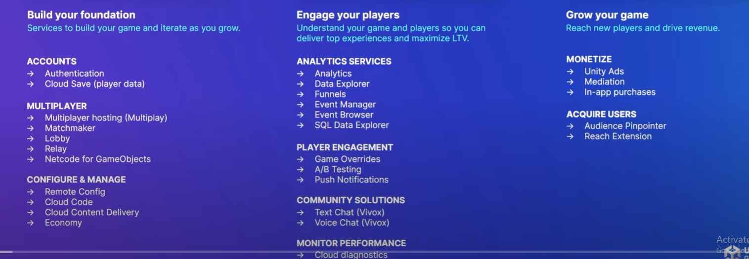

# Development Plan

The projects development has been broken down into stages/milestones and does more decomposition within each stage/milestone.

The first stage of the development process is the Design Documents stage. This stage includes the creation of technical design documents and the game design document. It also includes the creation of project plans with task lists and schedules. The goal of this stage is to establish a clear understanding of the project's scope, requirements, and goals by using and containing a task list and to do list, scheduling and board organization.

The second stage of development focuses on implementing the core gameplay mechanics and features. This stage is broken down into smaller sections, which include gameplay mechanics, backend tools, and multiplayer features. Each section is further divided into layers that allow for greater detail and precision. For example, in the mechanics section, layer 1 includes Movement, Audio, Aiming, Abilities, Spawning, Interaction, Target Lock-on, Ability indicators, Targeting, and Camera. Meanwhile, layer 2 includes Gamemanager, Animation, UI, Levelling up and exp, Calculation, Stats tracking, Monsters, and item Build. This stage is critical for establishing the foundation of the game.

The third stage of development involves networking and implementing multiplayer features such as friends, and the ability to play games with others, voice chatting and text chatting. This stage is focused on making the game more social and connected.

The fourth and final stage of development is polishing and full-scale optimization. This stage is where the game is refined to remove all the possible bugs and made to be smoother and faster on most devices it is available for. It includes the removal of bugs throughout the game, the optimization of graphics and code, and any other final touches that may be needed which would which further improvement on the game architecture and other visual improvements. The goal of this stage is to create a polished and well-optimized game with smooth gameplay, visually appealing sights, and faster game navigation.

|  |  |  |
| --- | --- | --- |
| ***Milestone*** | ***Deliverable*** | ***Completion*** |
| *Pre-Production End* | **Complete Documentation**   * TDD * GDD * Project Plan * Task List and Schedule |  |
| *Mechanics* | **Specifics**   * Heroes * items   **Layer 1**   * Movement * Audio * Aiming * Abilities * Spawning * Interaction * Target Lock-on * Ability indicators * Targeting * Camera   **Layer 2**   * Gamemanager * Animation * UI * Levelling up and exp * Calculation * Stats tracking * Monsters * Build |  |
| Features | **Layer 1**   * Chest Opening * Loading Screen Minigame * Spins * Match data * Database storage * Match history * Inventory   **Layer 2**   * Menu navigation * tutorials * Levelling up and exp * Data tracking * Mailing/messages   **Layer 3**   * Preparations * Shops * events * IAP * Localization |  |
| Networking | **Layer 1**   * Region * Hero selects * Gamemode select * Game start and end * Money calculations * MVP/Score calculations * Gameplay management |  |
| Polishing and Optimization | **Polishing**   * Music & Sound Effects, Volume * UI Design * Game Architecture * Colour Combination * Animation/Rigging   **Optimization**   * Unity Profiler * Garbage Collection * Smoother gameplay * Better/more accurate physics and rigid body |  |
| Post-production | **QA Testing**   * **Gameplay** * **UI/ menu navigation** * **IAP** * **Jailbreaking** |  |

<https://risinghighacademy.com/how-to-add-polish-to-your-games/>

<https://www.buildbox.com/game-dev-101-adding-polish-games/#:~:text=To%20polish%20a%20game%20is,secret%20to%20making%20better%20games>.

Optimization

<https://unity.com/how-to/mobile-game-optimization-tips-part-1>

<https://blog.unity.com/technology/optimize-your-mobile-game-performance-tips-on-profiling-memory-and-code-architecture>

<https://blog.unity.com/technology/optimize-your-mobile-game-performance-expert-tips-on-graphics-and-assets>

<https://resources.unity.com/games/unity-e-book-optimize-your-mobile-game-performance>

## Project Objectives

The goal for the release is to be as developed as mobile legends was in 2016 when they first released their game, with a few characters that are expensive to purchase to encourage high player retention and longer play time this is because it takes longer to earn the money needed to unlock/buy heroes. The goal is to also be entertaining while having a robust networking system that is protected from hacking and doesn’t have bad matchmaking issues

## Finished Product Goals

Dynamic and customizable hero abilities: allow players to customize and upgrade their hero’s abilities, allowing them to create unique playstyles and strategies. Also have unique gameplay mechanics.

Interactable environments: Make the game’s environment more dynamic and interactive with bushes and turrets, allowing players to use them to their advantage.

In-game events and challenges: Add events and challenges to the game that offers unique rewards and gameplay experiences, keeping the game fresh and engaging.

Social features and community building: Include social features such as chat, leaderboards, and clan support to foster a sense of community, teamwork and competition among players.

Multiple Platforms: open to players on many different platforms such as tablets, iPads, windows devices and etc. to create a larger and more diverse player base as professionals tend to use bigger devices.

Diverse and well-balanced roster of heroes: A strong roster of heroes which offers a well-balanced selection of heroes which create unique playstyles and unpredictable gameplay.

The ability to create communities: allow players to create and build a positive and active community, this is done through social feature such as text chat and voice chat and community events.

High quality graphics and audio.

### Full Online Launch

We are releasing the game on as many mobile devices with language localization but the game is not going to be as complete as its competition. The game is largely reliant on population and the player base because if there aren’t many player in one region then there wont be many games happening and because of this the game won’t be playable. There are also other things because the game is just initial release and have a lot more updates rolling through with a lot more content such as ranked.

### More Levels

The current/basic gamemodes are already fun on their own and have their own appeal but more gamemodes can be made with many different rules and possibilities and allows for creative freedom to come out and may also allow heroes in the game to be more used especially in more unique ways and see new game mechanics.

### Sequel

Our game has a deep and thorough story which even deeper lore but it doesn’t have a sequel or lore and only has update and maybe in the future more cinematics and more characters

# Project Structure

## Project structure and naming File formats naming convention

The following tables describe the project structure and naming format for the game’s folder’s in-engine.

|  |  |
| --- | --- |
| **Directory** | **Files** |
| Assets\Scripts | All scripts and things involving scripts that I create will be here |
| Assets\Scenes | This will hold all the scenes for the game that I create and will use |
| Assets\Prefabs | These are for all the prefabs I create |
| Assets\Materials | This is for materials created, extracted and used in game |
| Assets\Animations | All animations for characters, ui and etc. |
| Assets\Scripts\Scriptable Objects | This will be where scriptable objects scripts and scriptable objects will be |
| Assets\Characters | character meshes, 3d models and other things pertaining to the character |
| Assets\ParticleEffects | particle effects and dependencies. |
| Assets\Environment | environment assets (meshes – materials – textures) |
| Assets\Shaders | This is where compute shader scripts will be placed |
| Assets\UI | These are UI things such as buttons, images, sprites and more |
| Assets\Maps | maps |
| Assets\Networking | Networking stuff |
| Assets\Sounds | sounds and sound cues |
| Assets\Plugins | All the plugins and assets downloaded either from the asset store or online will be here |
| Assets\Characters\Skins | Characters will have skins and sometimes multiple so this is where they will be placed |
| Assets\Images | This will be where all the images as stored, such as the pngs, jpegs etc. |

## General Naming Rules

The following rules will always be followed whenever a new asset is created with no exceptions unless strictly specified with proper documentation and reason behind it:

In the unity scripts there will be headers (using the header attributes) the headers separate the member variable by their purpose/ use case but to distinguish all variables.

Global member variables will have a prefix of “m_” and parameters/arguments will have a prefix of _ and local member variables will have no prefixes but will use camel case with the first letter being lower case.

The following table describes the project’s structure and naming format for the game’s asset’s in-engine.

|  |  |  |  |
| --- | --- | --- | --- |
| **Asset Type** | **Prefix/Suffix** | **Example** | **Comment** |
| Prefabs |  | Content | It will just be the name of the prefab as they can be anything and it can be decided whenever and there are also prefab variations |
| ScriptableObjects | _SO | Hero1_SO | This will be both the name of the scriptable object as an item in the project and as a global variable in scripts |
| Shader | SL_..Shader | SL_GlitchShader | SL is short for shade language |
| Particle systems | PS_/_PS | PS_BloodSplatter/BloodSplatter_PS | PS is short for particle system |
| Scripts |  | EventManager | Scripts don’t need anything because they have so many use cases and there are so many of them |
| Fonts | Font | HelveticaFont | This is just for searching purposes |
| Animation | _Anim | Run_Anim/ RunAnim |  |
| Material | mat_/_mat | mat_Hero/Hero_mat |  |
| Physics |  |  |  |
| Sound | _SFX/_Msc | Coin_SFX/Helena_Msc | You have 2 different types of audio, sound effects and music |
| Scenes | Scene | MenuScene |  |
| UI | _L1 | HeroSelectPanel_L1 | L1 is layer 1 and L2 would be layer 2 to show who is a chiled of who |
| Floats | m_F | m_Fhealth |  |
| booleans | m_B | m_BisDead |  |
| events | Event | PlayerDeadEvent |  |
| Enums | E | ERUNSTATEor ERunState |  |
| Int | m_ | m_Kills |  |
| delegates | ON | OnPlayerDead |  |

# Gamemodes

## Classic 5v5

This mode gives 5v5 and the Mobile Legends experience without worrying about losing your Rank, but your win rate will be affected, both from the hero side and the whole.​​​​ Classic Mode is suitable for beginners who need to familiarize themselves with Mobile Legends games. You can freely choose any hero you have

## Common Warfare - 3v3

a 3v3 game mode on Flatland Battlefield, using a much smaller map. In this version of the game, there is only one turret and a core base for both teams. These games are designed to be much quicker

## Charge - 5v5 1 Lane

This mode contains only one lane with two turrets defending the base in both teams respectively. Brawl matches usually end in a much shorter time compared to Classic Mode and Ranked. This type of match is best for raising lost credit scores due to reports and AFK behavior.

## 2 Front wars - 2v2v2v2 multi lane

*Unlike the conventional 5v5 map, different spawn points are belonging to the different teams on the map, as well as different stage events that occur at fixed intervals including different monsters that give the various type of buffs. The 4 teams face off against each other on the battlefield. Players gain points by defeating heroes from the other teams. The timer for the stage is fixed at 8 minutes. Once the 8 minutes are up, the teams are ranked according to their total scores, and the map scores are shown from 1st place to 5th place.*

# Asset List

## 3D Assets

Most of the assets listed here are shared throughout the game with some changes only for materials and/or texture, however, they will be done modularly for easier in-game implementation.

|  |
| --- |
| **Asset** |
| Bird |
| butterfly |
| Crystal Fragments |
| Fire |
| Fish |
| Fiish |
| Frog |
| River |
| Seal |
| Sparks |
| Waterfall |
| Ground terrain |
| Ground grass |
| Ground Moss |
| Ground Mud |
| Ground Stone floor |
| Ground stone floor moss |
| Death Character |
| Melee Creep red |
| Melee Creep blue |
| Creep archer red |
| Creep archer blue |
| Siege creep red |
| Siege creep blue |
| Bolt |
| Magic missiles |
| Magic Explosion |
| Zombie minion |

## Audio Asset List

You have the voice and audio for the characters and then you have the sound effects and background music.

|  |  |  |
| --- | --- | --- |
| Category | Unit Type | Unit Description |

## UI 2D Art

Our game will only require 2D Art Assets for the User Interface:

|  |  |
| --- | --- |
| **Asset** | **Asset Type** |
| Game Logo | Psd |
| Abilities | Psd |
| Box/Border |  |
| Character Potrait |  |
| Custom Symbols(all in one psd file) |  |
| Items |  |
| ALTRASHED-broken | ttf |
| Concerning Fonts | txt |
| PT_Sans-Web-Bold | ttf |
| PT_Sans-Web-BoldItalic | ttf |
| PT_Sans-Web-Italic | ttf |
| PT_Sans-Web-Regular | ttf |
| PT_Serif-Web-Bold | ttf |
| PT_Serif-Web-BoldItalic | ttf |
| PT_Serif-Web-Italic | ttf |
| PT_Serif-Web-Regular | ttf |
| Raven Moba Part 1 - General MOBA Elements | .psd |
| Raven Moba Part 10 - Draft | .psd |
| Raven Moba Part 11 - - Loading Screen | .psd |
| Raven Moba Part 2 - Artifact Store | .psd |
| Raven Moba Part 3 - Additional UI Elements | .psd |
| Raven Moba Part 4 - Log In Screen | .psd |
| Raven Moba Part 5 - News, Profile, Social, Nav Bar, Chat | .psd |
| Raven Moba Part 6 - Shop | .psd |
| Raven Moba Part 7 - Hero Selected | .psd |
| Raven Moba Part 8 - Map and Mode | .psd |
| Raven Moba Part 9 - Party | .psd |
| Health Bar Material | .mat |

# Coding Conventions

## Coding Naming Conventions

* The first letter of each word in a name (such as type name or variable name) is capitalized, and there is usually no underscore between words. For example, Health but not lastMouseCoordinates or delta_coordinates.
* Type names are prefixed with an additional upper-case letter to distinguish them from variable names. For example, FVector3 is a type name, and Vector3 is an instance of a Vector3 which can take in floats .
  + **Template** classes are prefixed by **T**.
  + Classes that Interfaces prefixed by **I**.
  + Functions and/or classes that inherit from **Abstract** are prefixed by **A**.
  + Enums are prefixed by **E.**
  + Boolean variables must be prefixed by **b** (for example, bPendingDestruction, or bHasFadedIn).
  + Most other classes are prefixed by **F**, though some subsystems use other letters.eg:
  + No prefix must be added to primitive types :
    - * **float AttackDamage;**
      * **int AttackIndex;**
      * **bool bCanAttack;**
      * **string AttackName;**
      * **Transform AttackPosition;**
      * **GameObject AttackSound;**
* Functions that return a value should describe the return value. The name should make clear what value the function will return. This is particularly important for boolean functions. Consider the following two example methods:

[what does true mean] **bool CheckAttack(Transform Attack)**;

[name makes it clear true means player is attacking] **bool IsAttacking(Transform Attack)**;

## General Coding Rules

Acceptable and Unacceptable Blueprint examples:

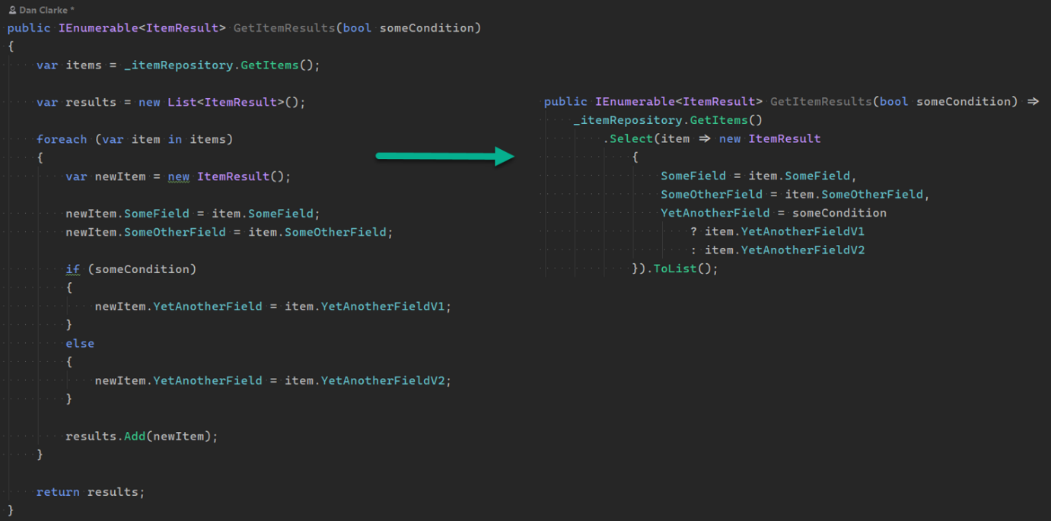

Left is unacceptable, Right is acceptable

### Guidelines

* Write self-documenting code:

// **Bad**: t = s + l - b;

// **Good**: TotalLeaves = SmallLeaves + LargeLeaves - SmallAndLargeLeaves;

**Write useful comments:**

// Bad:

**// increment attack**

++AttackIndex;

// Good:

**// cycle through the attack sequence**

++AttackIndex;

### The 'auto' Keyword (Please Try to Avoid)

**When is it acceptable to use auto/var?**

* For iterator variables, but only where the iterator's type is verbose and would impair readability.
* In template code, where the type of an expression cannot easily be discerned. This is an advanced case

### Lambdas and Anonymous Functions (Lets Keep it simple)

Try to avoid using Lambdas but can be used if all the programmers are in accordance with it.

### Strongly - Typed Enums

enum class **EThing**

{

   Thing1,

   Thing2

}

## Code Formatting

Always include braces in single-statement blocks. For example.:

if (bThing)

{

   return;

}

**If - Else**

if (bHaveUnrealLicense)

{

   InsertYourGameHere();

}

else

{

   CallMarkRein();

}

### Switch Statements

switch (condition)

{

   case 1:

       ...

       // falls through

   case 2:

       ...

       break;

   case 3:

       ...

       return;

   case 4:

   case 5:

       ...

       break;

   default:

       break;

}

## Namespaces: Do we really need those?

Just use forward declaration!

# Project Technical Details and explanations

## Game Terminology

### Attribute Guide

|  |  |
| --- | --- |
| **Name** | **Description** |
| Valors/Valorians/ Valkyries | Valors is a gender-neutral name for people who are involved in the war and fight. Valorians is used for males and Valkyries is used for females. Because some of these people are the furthest thing from heroes |
| Health Points (HP) | The amount of health of a Valor, can be increased by buying items. The Valor dies once the number reaches zero. |
| Nazomeita | An attribute of a hero that indicates their power to cast skill ability. |
| Physical Attack | An amount that increases the physical damage of skills using its skill coefficient. |
| Nazomeita Power | A type of damage that triggers Nazo Lifesteal, Nazo Penetration, and Critical Chance. |
| True Damage | A type of damage that ignores both Physical and Nazo DEF. Also dealt by Legend creeps. |
| Physical Lifesteal |  |
|  |  |

### State Guide

|  |  |
| --- | --- |
| **Name** | **Description** |
| Stunned | Prevents a target from moving, attacking, or using skills. |
| Frozen | Prevents a target from moving, attacking, or using skills. This is an advanced stunning effect and will not be affected by CC time reduction. |
| Suppressed | Prevents a target from moving, attacking, or using skills. This is an advanced stunning effect and can't be removed. |
| Airborne | Prevents a target from moving, attacking, or using skills. The target will fly into the air within the duration. |
| Transformed | Prevents a target from attacking or using skills. The target will be transformed into other creatures. |
| Silenced | Prevents a target from using skills. |
| Immobilized | Prevents a target from moving and interrupts Blink, The target can't use Blink within the duration. |
| Horrified/Feared/Terrified | Prevents a target from attacking or using skills. The target will move randomly within the duration. |
| Taunted | Forces a target to do Basic Attack to the caster. The target can't use skills within the duration and will attack the caster again. |
| Disarmed | Prevents a target from attacking using Basic Attacks. |
| Untargetable/Invincible/Invulnerable | Where a hero can be locked onto, taking no damage within the duration. |
| Control Immunity | Where a target will not be affected by any Control Effects. |
| Slowing Immunity | Where a target will not be slowed down. |
| Speed-Up | Increases Movement Speed. |
| Stealth/Conceal | To be invisible to enemies. |

### Common Terms Guide

|  |  |
| --- | --- |
| **Name** | **Description** |
| Iron Imperials/ Warlords/ Battle Titans/ Bezerker | A player who got the highest score in the team that can be seen through Post Game. |
| Piling Bodies | Killing 3 enemy heroes with no death. |
| Slaughter | Killing 4 enemy heroes with no death. |
| Carnage | Killing 5 enemy heroes with no death. |
| Bloodbath | Killing 6 enemy heroes with no death. |
| Massacre | Killing 7 enemy heroes with no death. |
| Somebody Stop Them | Killing 8 or more enemy heroes with no death. |
| Butcher | Consecutively kill 2 enemy heroes in a short period of time. (The kills have to be 10 seconds apart) |
| Extermination | Consecutively kill 3 enemy heroes in a short period of time. (The kills have to be 10 seconds apart) |
| Rampage | Consecutively kill 4 enemy heroes in a short period of time. (The kills have to be 10 seconds apart) |
| Bullied/Bully | Consecutively kill 5 enemy heroes in a short period of time. (the kills have to be 10 seconds apart) |
| Stopped | When successfully kill a hero who has 3 or more kills with no death. |
| Turtle | A special monster on the battlefield. Heroes will get special BUFF and extra Gold Bonus to all ally heroes after killing it. |
| Monarch of Mayhem | A special monster on the battlefield. Heroes will get Gold Bonus after killing it. One Luminous Lord will attack with them. |

### Medals Terms Guide

Medals are given after every match. Medals depend on your grade during the battlefield.

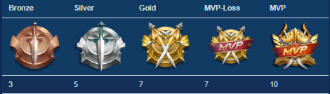

<https://mobile-legends.fandom.com/wiki/Terminology>

## Features

### Chest Opening/Lootboxes and Ad boxes

**Overview**

The chest opening is how the players close the gap between the F2P and P2P and also a way for them to have some fun and test their luck because in a Chest opening (Have a unique name for it). Because with chest opening anything is possible, you could get money, expensive skins, characters or just emblems and other dud items and if they get a character, they already have it goes in their inventory and then they have the ability to sell it for money based on what the character or skin is worth and it can stack. There will also be some skins that are pack only and it will show the grade of the item. You can also purchase them for real money. Another thing is that each item is independent of the other items in the loot box in terms of grades, so just because you get a super rare grade as the first item doesn’t mean you cant get it 2 more times (assuming you get 3 items per chest)

Pity Tracker

The chances of any legendary item dropping from any individual lootbox is 1 in 100, so if you bought 100 to increase your chance of getting a legendary or Super. Using binomial you can calculate the probability which is approximately 0.634. This means in 100 lootboxes there is a 1 in 3 chance that we don’t get a legendary and if you buy 200 lootboxes there is a 1 in 7 chance you still don’t get a legendary. So a pity tracker guarantees a legendary after a certain number of failed pulls.

The formula for probability is:

|  |  |  |
| --- | --- | --- |
| Odds | Lootboxes | probability |
| 1 in n | n | 1- ((n-1)/n)^n |
| 1 in 1 | 1 | 1.0 |
| 1 in 2 | 2 | 0.75 |
| 1 in 3 | 3 | 0.7037037 |
| 1 in 4 | 4 | 0.68359375 |
| 1 in 5 | 5 | 0.67232 |
| 1 in 6 | 6 | 0.66510202 |
| 1 in 7 | 7 | 0.66008332 |
| 1 in 8 | 8 | 0.65639108 |

If you open a lootbox 3 items come out from a massive pool of possible loot, to fairly select those 3 pieces of loot we categorize them into tiers of rarity with low tier items being the most common and the precise values of their tier weights is all about balance. The mechanism is to randomly select a tier based on its weighted probability and from that teir and the pool of loot that lives in it, select a random item to repeat this. We can model the weights in 2 different ways: absolute or relative.

Absolute shows the probability of getting an item from a tier relative to the whole

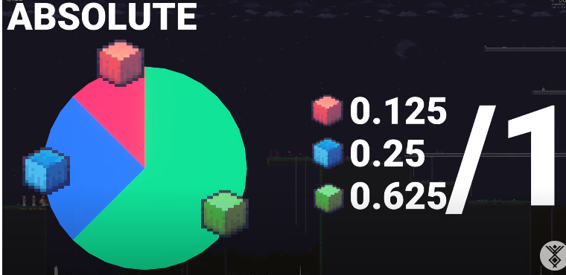

Relative shows the likelihood of getting an item from a tier relative to an arbitrary base but we don’t know the probability against the whole. Its much easier to change and more flexible

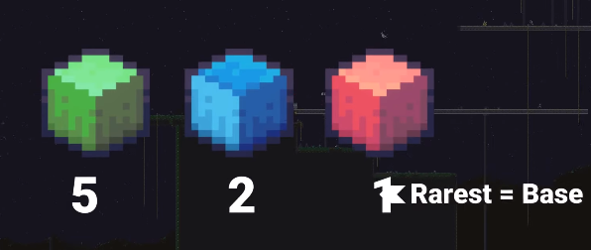

We can implement these through a cumulative distribution function using a pie chart with each segment, showing the relative weight of each tier

**Visualization**

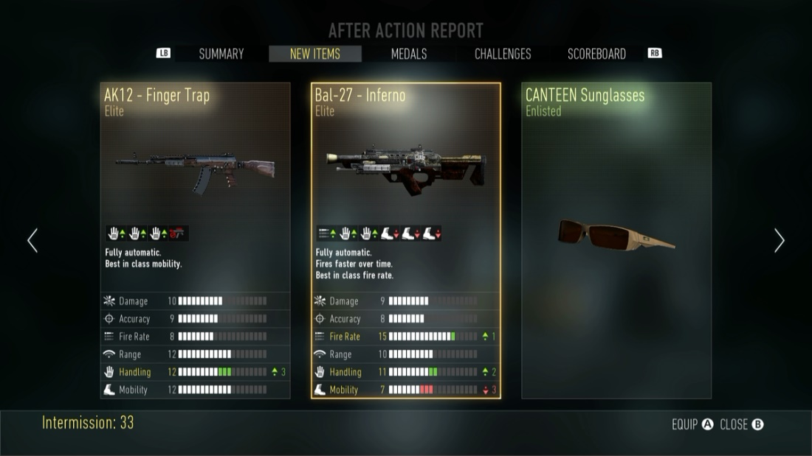

Screenshot of Possible Lootbox opening. Disclaimer: Lootboxes are from 2 different games.



Screenshot of third successful attack. Disclaimer: animation is not ours and was used only for testing combos on prototype.

**Table of Metrics**

|  |  |
| --- | --- |
| **Name of grade** | **Probability** |
| common | 65% |
| Normal | 20% |
| rare | 11% |
| Special | 3% |
| Super | 1% |
| Impossible | **0.00001%** |

**Code**

So There could be a class called ItemGrade which each item has or an enum but most likely a class and one of the most important things you have to set is the actual grade and each grade come with its own percentage probability. You could decide each item based on probability

E.g. this is an example of throwing a loaded dice

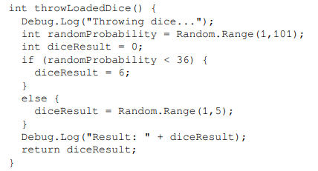

We can write the probability for an event A to occur as P(A). To calculate P(A) we need to know all the possible outcomes (N) for the observation and the total number of times in which the desired event occurs (n). So, the probability of an event A can be calculated as the following

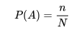

// ref - Unity Artificial Intelligence Programming Fourth Edition by Dr. Davide Aversa Aung Sithu Kyaw Clifford Peters

This is an example of a Random slot machine

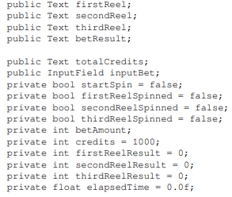

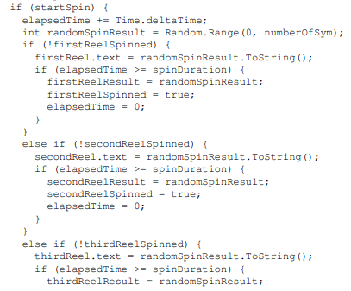

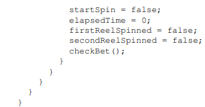

Weighted probability

Real slot machines have something called a Paytable and Reel Strips (PARS) sheet, which is like the complete design document of the machine. The PARS sheet is used to specify what the payout percentage is, the winning patterns, what their prizes are, and so on. Obviously, the number of the payout prizes and the frequencies of such wins need to be carefully selected so that the house (the slot machine) always wins in the long run while making sure to return something to the players from time to time to make the machine attractive to play.

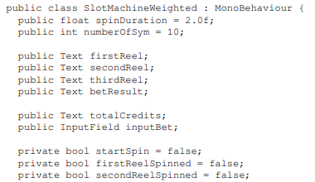

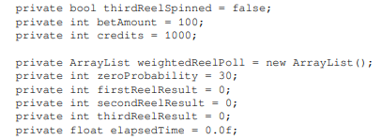

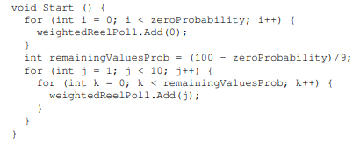

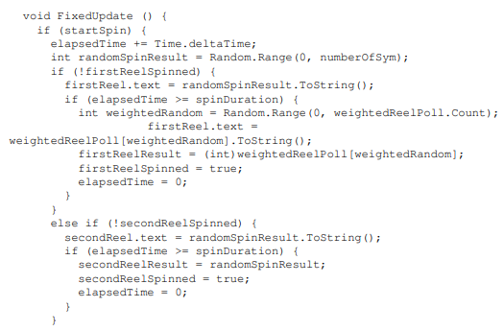

Near miss

If the first and second reels return the same symbol, then we have to provide the near miss effect to the players by returning the random value to the third reel close to the second one.

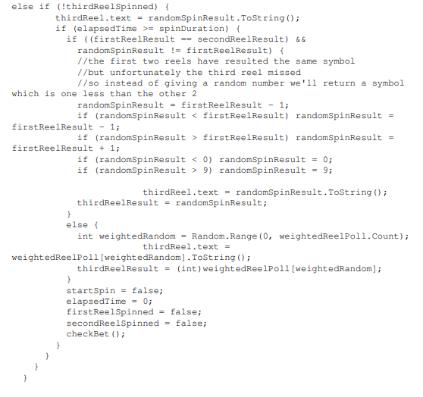

we'll not be focusing on choosing the optimal value for the house to yield specific wins over time, nor maintaining a particular payback percentage. Rather, we'll be demonstrating weighting probability to specific symbols, so that they show up more times than usual. So, let's say we'd like to make the zero symbol to appear 20 percent more than usual on the first and third reel, and return half of the bet as a payout. In other words, a player will only lose half of their bet if they got zero symbols on the first and third reels, essentially disguising a loss as a small win.

The code for the AD boxes will just be the same as the code for the ad reward.

There will a pity tracker and there will be a bool function that checks if a chest/lootbox got a legendary if you didn’t get a legendary then the next one will have a legendary and once the pity tracker hits 0 then it resets (it reduces each time you fail to get a legendary). If you then get a legendary in the chest and the pity tracker is 0 you get 2 legendries.

How the pity tracker works is – when it hits 0 then the probability of getting a legendary goes to 100 and then it randomly chooses which slot/ roll a legendary should be in, in the COD example it could be the first, second or third one.

So its less predictable bought lootboxes reduces the pity tracker by 2 or 3 and earned reduces the pity tracker by 1 everytime.

The probability of getting a lootbox at the end of the game is affected by your performance, if you do good you’ll most likely get a loot box and the same applies to ad boxes but the base rate is higher for adboxes

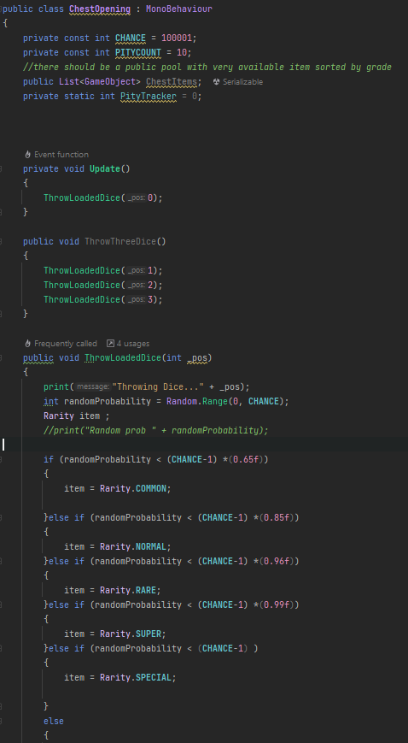

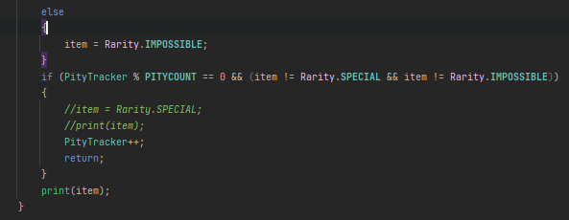

### Minigames in the Loading Screen

**Overview**

<https://www.youtube.com/watch?v=KfFnMh-KYHI>

Just like in dragon ball games during the loading screen you will be able to play mini games and the minigames will be based on different characters for example your hero you chose could be a random character and then your mini game could be a Nadia mini game and you need to tap to shoot and you score goes up and it tracks your score.

All the minigames will be tapping minigames and they would be based off of the heroes.

It may keep the high score.

**Visualization**



Player Taps on screen repeatedly to get a score and it is not necessarily a tap a score each mini game would be different e.g. one minigame will be one tap per score and another may be 4

**Table of Metrics**

|  |  |  |
| --- | --- | --- |
| **Name of hero** | **Minigame** | **Taps per score** |
| Ali | Tree climb: You would tap on the screen to go up a tree and when you do you go up, once you reach a certain score you will pushed down by a random number | 1 |
| Cannon Fanum | Fire in the ole!! : The player taps the screen to pick the canon, load the canon an shoot the canon off the screen | 3 |
| Nadia | Deadeye: tap to shot target down (could be the target could come up anywhere and you have to tap on the target to get the score) or you could shoot the target and position doesn’t matter | * 1. 2 |

**Code**

This will done asynchronously as the game will be loaded while the game. This helps cut down the loading screen time the user sees.

Step 1, load data for the scene from disk into memory. This step is the one that's able to be done asynchronously. Step 2, activate the new scene (e.g. call Awake and OnEnable for all enabled objects in the new scene). This step is not asynchronous.

<https://forum.unity.com/threads/starting-async-load-causes-massive-lag-spike.288755/>

<https://medium.com/@grand_reality/authentication-in-unity-login-register-user-accounts-in-5-minutes-7c29f378153e>

<https://blog.unity.com/technology/optimizing-loading-performance-understanding-the-async-upload-pipeline>

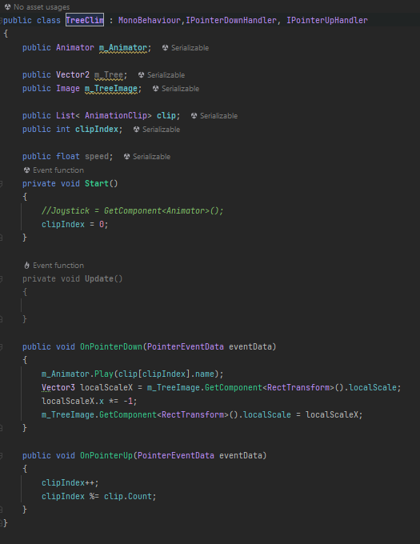

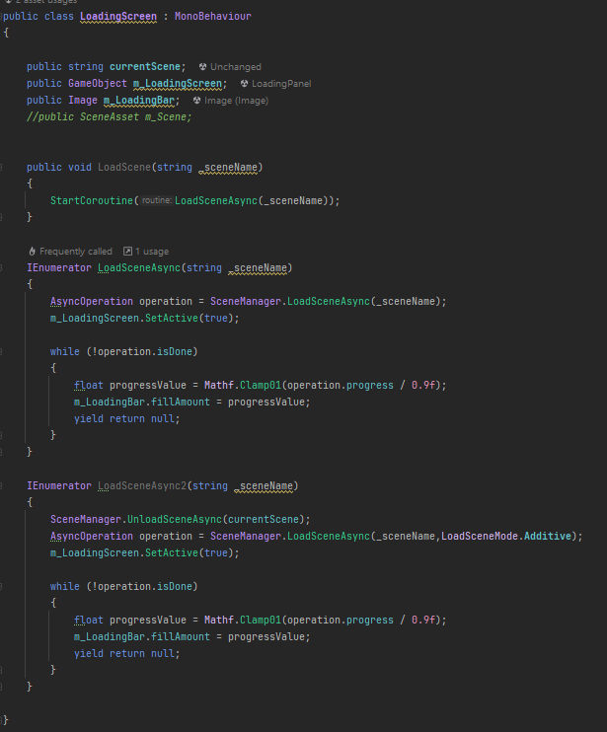

### Login

**Overview**

The user will have 3 options to login, they can use their google play games to login, they apple iOS to login or they can use Facebook to login and there will be no guest account. This can either be done using universal SDK plugin. After users have logged in or sign up, they will either be taken to the main menu or the account set up page. Also, if you’re on android you will not see the iOS option and if you’re on iOS you will not see the google option. However, this may be changed with google play games instead of google login as that has more benefits.

**Visualization**

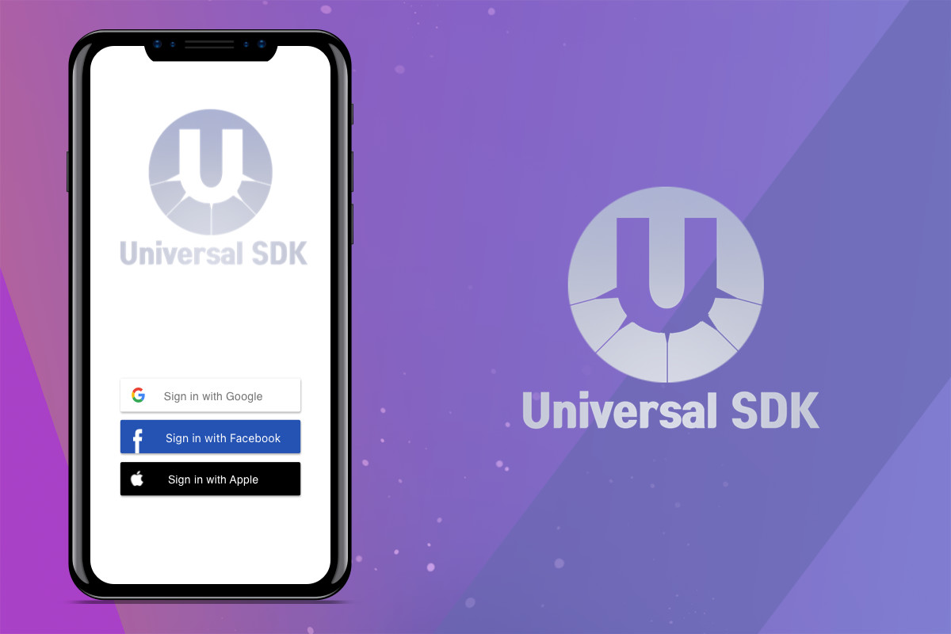

Once a player has signed up, they no longer see this option and are taken straight to the game.

#### Cloud saves.

<https://docs.unity.com/authentication/en/manual/platform-signin-google-play-games>

<https://unity.com/products/cloud-save>

**Code**

<https://unity.com/products/authentication>

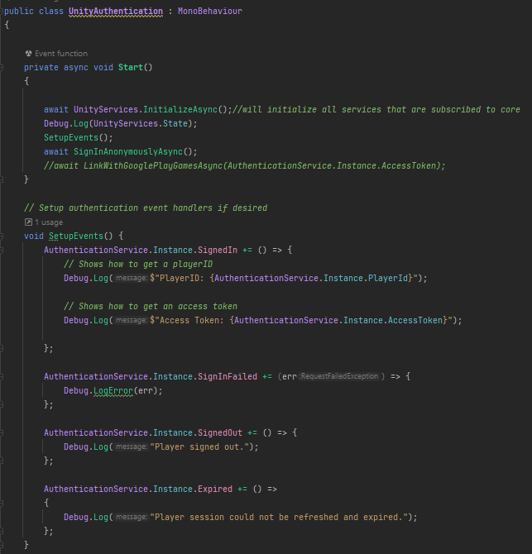

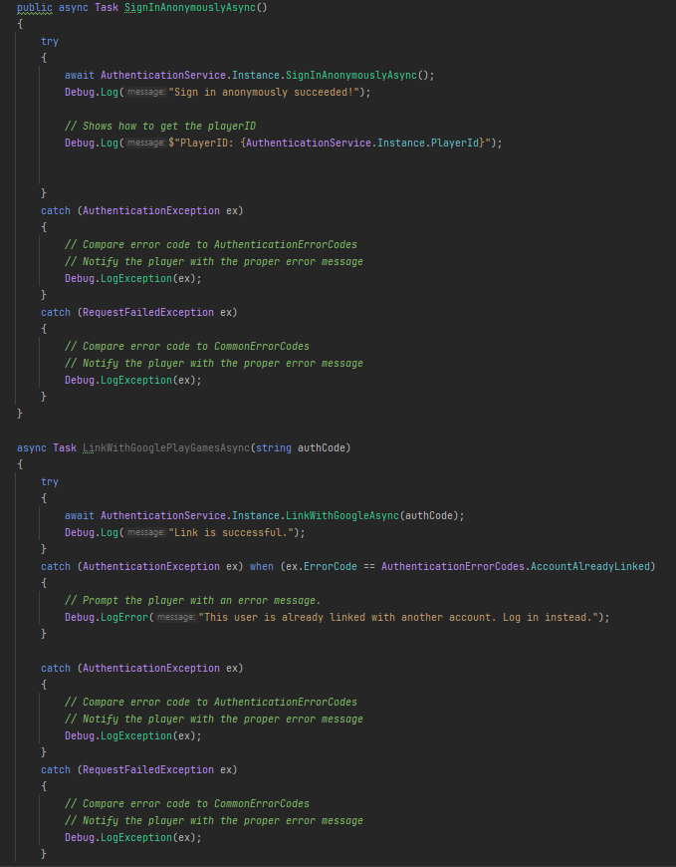

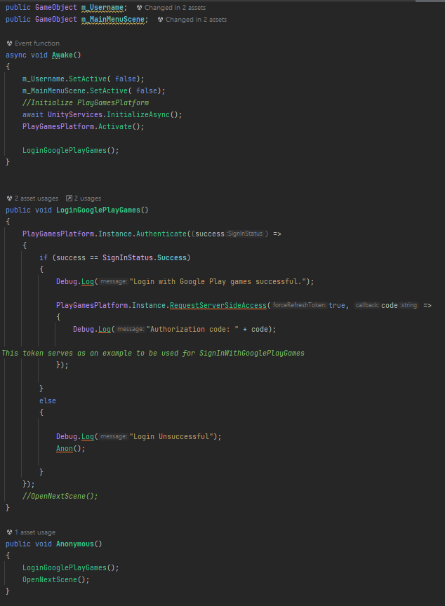

### Spin for rewards

**Overview**

The way this works is when you first load into the game you have events pop up but you also get daily free spin and on the free spin not each arc in the wheel is of equal size and everything in the wheel is quantity based

**For example:** 1000 coins will be smaller than 20 coins and 100 gems will be smaller than anything but the possibility to get them is there unlike mobile legends in which the only way to get anything is through paying even random luck games.

**Visualization**

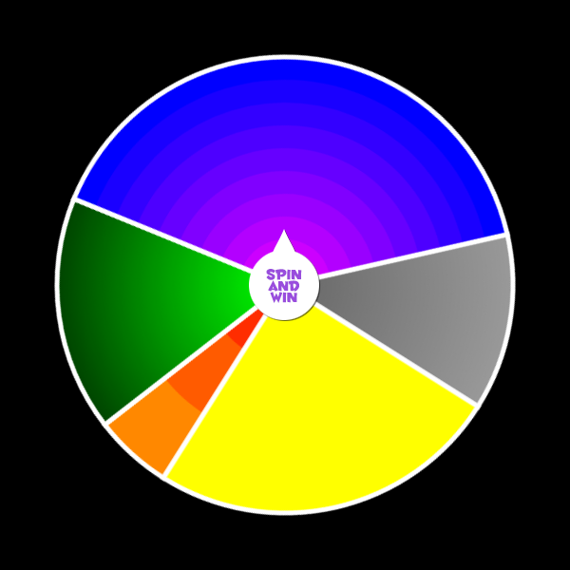

Example of the spinner

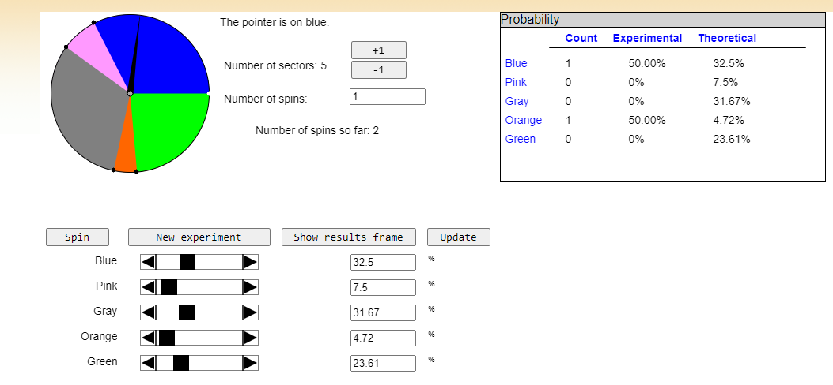

Adjustable percentages but they all add up to 100.

<http://shodor.org/interactivate/activities/AdjustableSpinner/>

This is a mock up, for reference the cost of the most expensive character is 40k and per game (assuming it’s an excellent game) 135.

To use gems is 250 to buy heroes and skins are 340

Tickets

**Table of Metrics**

|  |  |
| --- | --- |
| **Prizes** | **Percentage** |
| 100 coins | 20.83 |
| tickets | 25.11 |
| 150 gems | 5.28 |
| emblems | 37.22 |
| More gems | 3.33 |
| 28k coins | 7.22 |

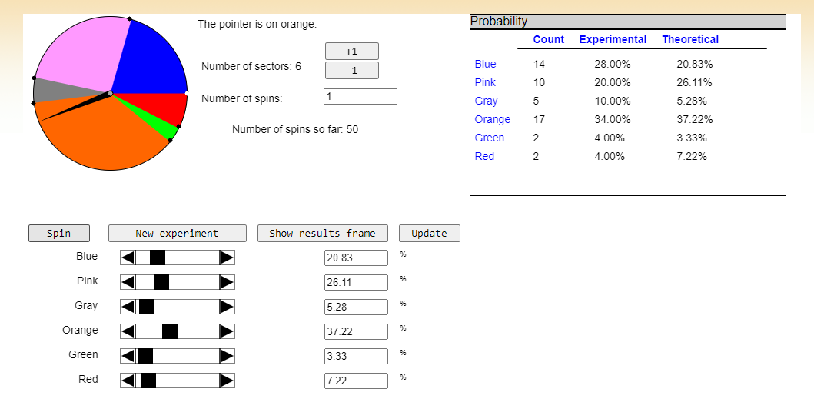

This is the result of 50 spins. Blue = 100 coins, Red = 28k coins

**Code**

This will use scriptable object for each arc the scriptableobject will contain

Integer amount

Enum for what amount

Enum prizeType{

Coins,

Tickets,

Gems,

Emblems

}

Then in the wheel of fortune there will be a slider for percentages that all add up to 100% and they can be modified

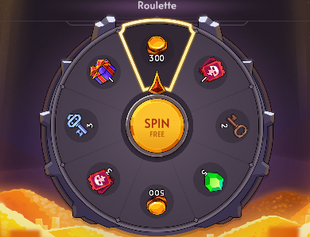



### Match data

O**verview**

This is going to be data from the game that will be measured through out th game in its own manager and it will contain things like:

* Match Time
* Team Kills
* *Damage dealt*
* *Damage taken*
* *Turret damage*
* *nazomeita used*
* *heals given*

**Visualization**

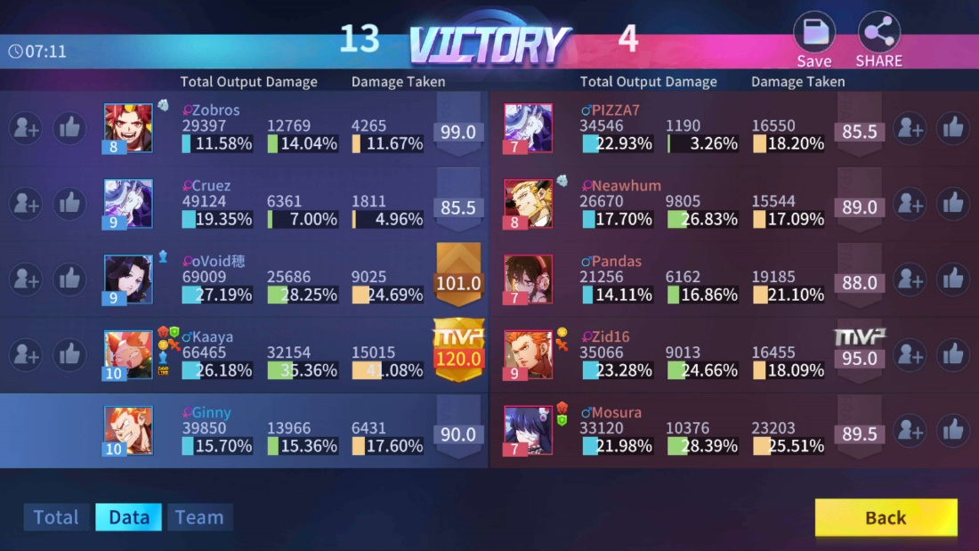

Percentages of things in the game

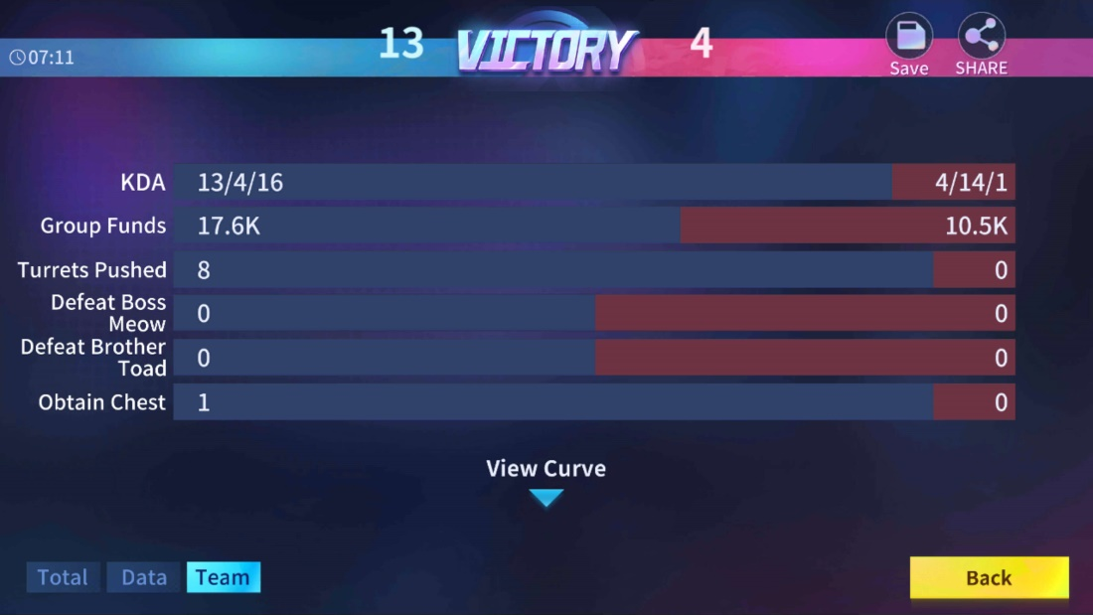

Other metrics

**Table of Metrics**

Code

Create a Class for metrics and have it keep track of everything such as Match Time, Team Kills*, Damage dealt, Damage taken, Turret damage, nazomeita used, heals given and then at the end of the game the game manager will get all the data from all the player and then add it up and then get the percentages from that class.*

*The class will also have methods for this stuff and then the game manager will have this as a variable.*

### Match History

**Overview**

When the Bloom bar is filled the Demon bloom mode activates and the player can choose when to use it to its advantage. There are certain features of this ability:

* Do more damage: When activated players do more damage with the same attack for a certain period of time.
* Take less damage: While getting a buff on attack players rather take less damage when this is activated.
* Health Regen: The health of the player gradually regenerates while using this ability.

**Visualization**

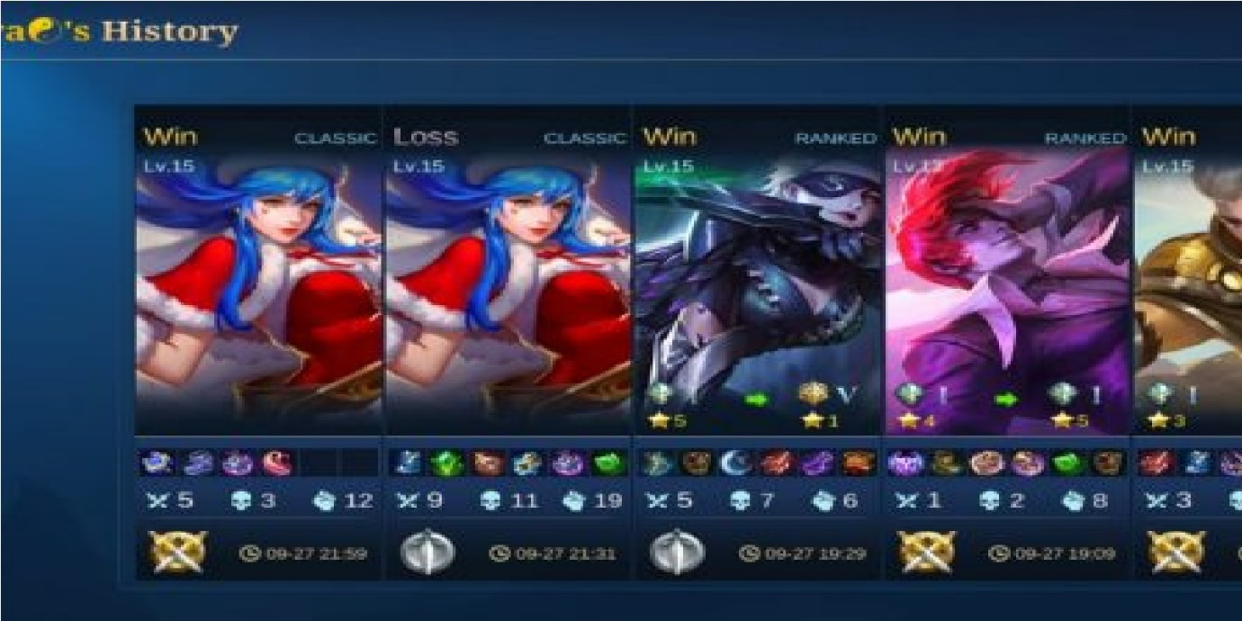

The games the player has played will be recorded and they will be able to open them and it will be

**Table of Metrics**

Code

The code for the account will have a attack of match data and the max will be x amount and then there will be another class that will be for the icon and that class will contain things like a win or loss enum, basically this call will contain and store all the information

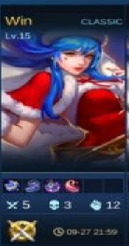

Then create a dictionary on the individual icon and the match history

### Inventory

**Overview**

The player will have an inventory that will contains things like skins, emblems and other items in the game and will store many things for the player. Each inventory will have a use and very few will have a use AND sell button

**Visualization**

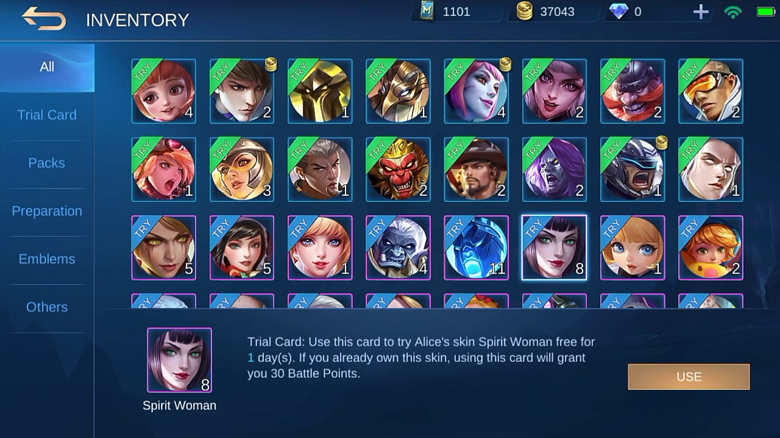

inventory

**Table of Metrics**

|  |  |
| --- | --- |
| **Items** | **use** |
| Diamond/gem coupons | Takes you to the shop |
| skins | Activate the skin. If skin is already owned then sell the skin |
| hero | Activate the hero for permanent use. If the hero is already owned then sell the hero |
| Magic dust | Takes you the emblem brewery |
| Emblem | Takes you to the emblem shop |
| Chest boxes | Opens the chest box |
| Ad Boxes | Activates the ad box |

Code each item that can be put in the inventory will have a inventory interface and the function in that interface will be use and then the inventory item will have something like a bool called can use and each use function will be different based on certain parent classes. E.g. a parent class could/would be

### Tutorials

**Overview**

The player will have an inventory that will contains things like skins, emblems and other items in the game and will store many things for the player. Each inventory will have a use and very few will have a use AND sell button

**Visualization**



inventory

**Table of Metrics**

|  |  |
| --- | --- |
| **Items** | **use** |
| Diamond/gem coupons | Takes you to the shop |
| skins | Activate the skin. If skin is already owned then sell the skin |
| hero | Activate the hero for permanent use. If the hero is already owned then sell the hero |
| Magic dust | Takes you the emblem brewery |
| Emblem | Takes you to the emblem shop |
| Chest boxes | Opens the chest box |
| Ad Boxes | Activates the ad box |

Code each item that can be put in the inventory will have a inventory interface and the function in that interface will be use and then the inventory item will have something like a bool called can use and each use function will be different based on certain parent classes. E.g. a parent class could/would be

### Voice Chat

<https://www.youtube.com/watch?v=XCqi0B1zqko>

## General Reference Table of Metrics

|  |  |
| --- | --- |
| **\*MAJOR REFERENCE** | **Specification** |
| Valeria and Irene’s health | 50 units of health. |
| Grunt’s health | 5 units of health. |
| Commander’s health | 20 units of health |
| “uu” units | Stands for **U**nreal **Units**, where 100 **uu** is 1 meter |

## Mechanics

The following are the mechanics that our players will execute throughout the game’s experience.

<https://mobile-legends.fandom.com/wiki/Terminology>

### Movement

**Overview**

The movement will be a joystick-based movement from the plugin and will be sensitive to axis so if I move the joystick by a bit the player will move by just a little bit but if I push the joystick to the extent the player moves at max speed.

The joystick has many options such as: static, Partial static(when the joystick moves with the players finger), No joystick

**Visualization**



T**able of Metrics**

Code

This would use things like simple.input for the joystick

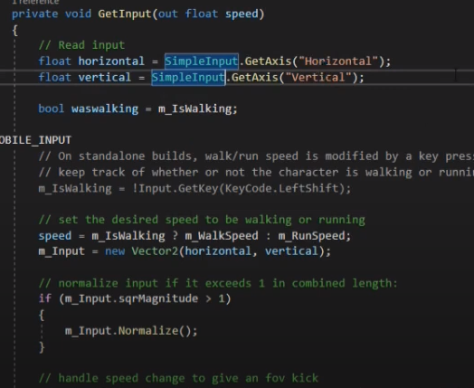

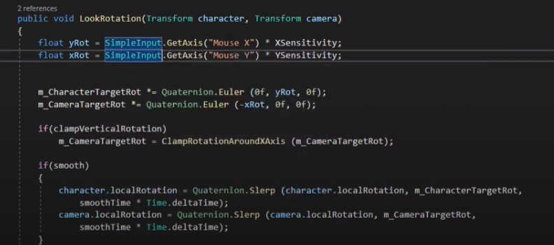

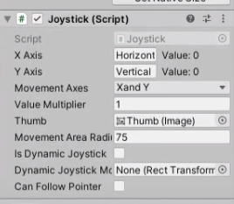

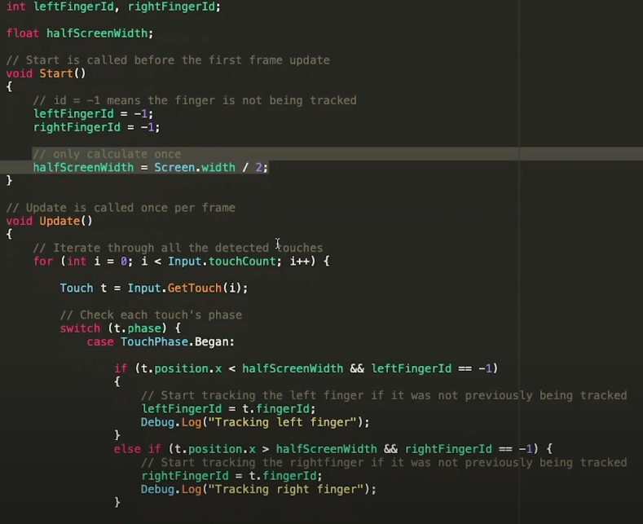

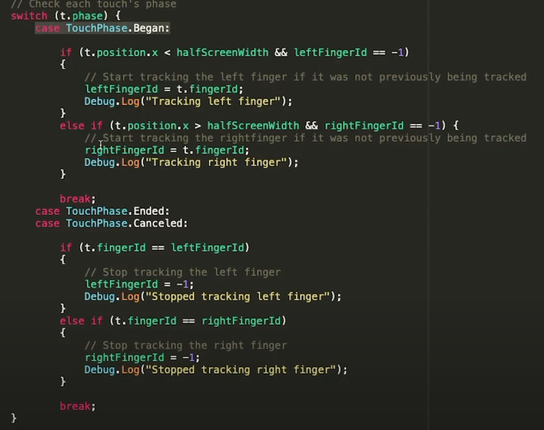

### Audio

**Overview**

There are many things that encompasses Audio and will require different scripts. The things that fall under audio are voice lines, game audio, attack sounds, you also have in match announcements, then there’s music (background sound) because some if not all will be used and triggered at different times.

<https://mobile-legends.fandom.com/wiki/Announcer>

<https://zathong.com/mobile-legends-voice-lines/>

<https://www.youtube.com/watch?v=ccyvuL-9rJ4&list=TLPQMTMxMTIwMjJyVsg-cclY_Q&index=2>

**Visualization**

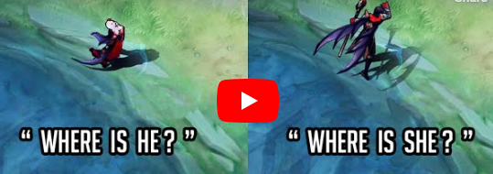

**Table of Metrics**

**Announcer Lines**

|  |  |
| --- | --- |
| **Event** | **Voice Lines** |
| Start Game |  |
| Kill |  |
| Enemy Kills |  |
| Objective |  |
| Signals |  |
| Quick chat |  |
| End |  |

There are different voice lines because not only do the heroes have their normal quotes the have their movement quote, death quote selected quote etc.

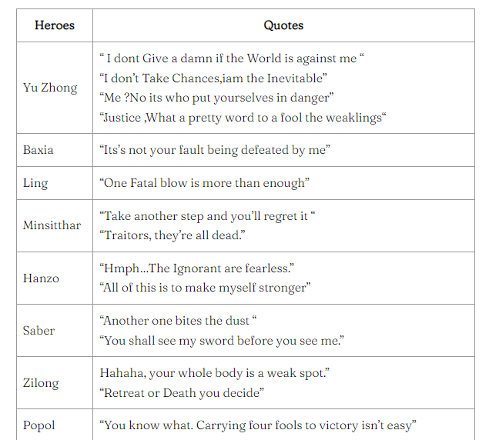

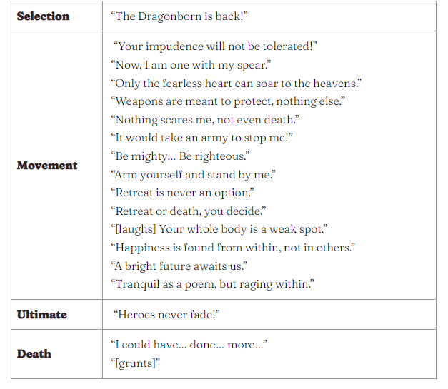

Code

This could be done by events or using an XML file or scriptable objects for example every hero could have a script and in the script have a scriptable object variable called voiceLines

And that scriptable object will have a list of voice line for each section e.g. List<audio> m_Movement audio, m_SelectionAudio, m_UltimateAudio and you could put the audios for them into that list and then have functions in the scriptable Object called getRandomMovementAudio and it return a random movement audio

[https://learn.unity.com/tutorial/sound-effects-scripting#](https://learn.unity.com/tutorial/sound-effects-scripting)

### Aiming

**Overview**

This is the both the aiming for the player attacking enemies, attacking the turret and attacking the minions and the player aiming and attacking other players with their ability. This is how it works for basic attacks, there can be 3 attack buttons the main attack button and 2 side attack button that will either lock to the monsters or the turret

The player will 3 basic attack settings:

Basic: This is where there is only one basic attack button (main basic attack button), this will attack the highest priority this priority system is based on whether the object within the players range is an enemy, monster or turret (the priority for that is Enemy hero then monster then turret, there may be an option to change that) then once the attack priority has been chosen then the target priority will be chosen after that and that’s when the player attacks.

Advanced aim: is a bit more precise than that but still the same thing just that there are two more buttons to specify what you attack.

Lock on aim: this will just allow the player to lock on heroes and not the turrets or minions but in later updates it will open.

Aiming also encompasses ability aiming and there are many forms of this

But aiming for abilities will only work on heroes assuming there aren’t abilities that work on turrets but until then the auto aim to hero and if no hero is nearby they aim in the direction of the finger.

**Visualization**

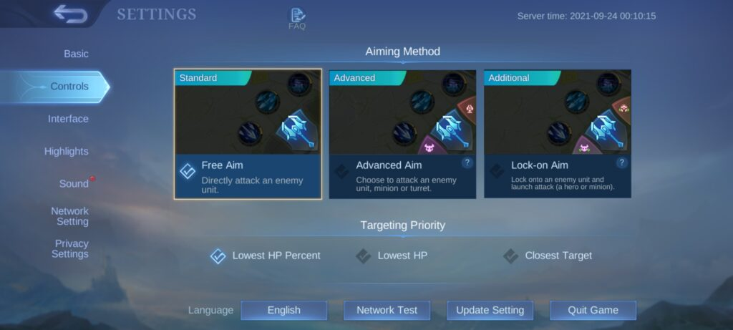

**Table of Metrics**

Code

So for the aiming it would be like this. Every hero has a universal target radius this radius is not seen by the player and will always be slightly bigger that the player’s attack radius and it gets everything within that radius, and it does calculations it gets all the objects in that larger radius and checks whether they are withing the smaller radius before attacking but moves towards them if they are not. It does the attackpriorityCheck first using a function and then a TargetPriorityCheck which checks for

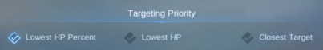

When aiming an ability, this should use the joystick that spawns at the position of the ability and for direction based abilities it should just copy the vector of the analogue and the center of the ability and give that vector to the pointer.

When it comes to radius based abilities, how it calculates this is based of percentages or I can do it based on vector scaling and there will be no normalizing

### Spawning

**Overview**

This is the spawning of the Lord the turtle, the minions and the jungle monsters. They all spawn differently for example the buffs in mobile legends spawn at the beginning and when they’re killed by a player they get a buff and that buff has a timer and once the timer runs out a few seconds after they spawn again, but for the other jungle monsters they spawn before the buffs at the beginning of the game and when they die a few seconds after they die the spawn again and the turtle spawns after like 5 minutes and the turtle also gives buffs and respawns but after a certain time the turtle stops spawning and the lord spawns, the Lord attacks all players attacking it at once then when defeated he attacks like a minion for the team that defeated it and a new type of minions spawn along with the lord.

The minions have different types of spawning such as the first wave which are easier to kill because everyone is weaker early game, the you have the normal wave which are the regular wave where some are difficult to kill and some are easy this is mainly for taking down towers. Then you have the armour wave which are bigger and far stronger and are made for taking down the inhibitor towers and the main tower. Then you have the lord’s minions which are gold plated and last for a few waves but the waves always default back to the normal wave.

<https://mobile-legends.fandom.com/wiki/Jungle>

<https://mobile-legends.fandom.com/wiki/Minions>

**Visualization**

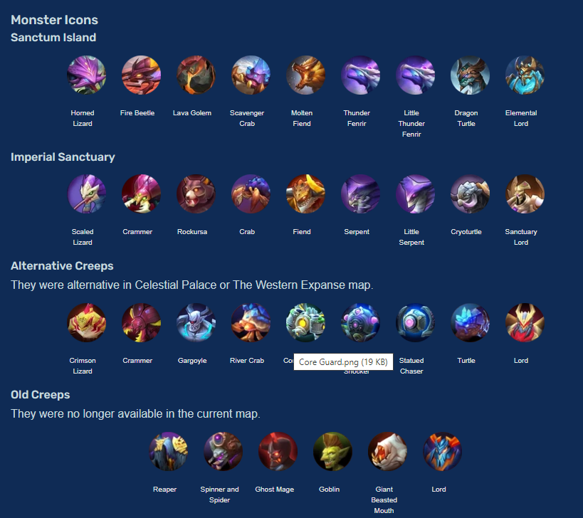

**Table of Metrics**

|  |  |  |
| --- | --- | --- |
| **Monster** | **Buff** | **Timer** |
| Maximum number of consecutive jumps. | There is a maximum of **1** jump per input. There is no double jump. |  |
| Cooldown between jumps. | There is a cooldown per finished jumped and a potential second one of **2 seconds**. |  |
| Jump height | Both main characters will jump **50 uu** up. |  |

**Table of Metrics 2**

|  |  |  |  |
| --- | --- | --- | --- |
| **Minion** | **Extra info(e.g. range)** | **Defence** | **Offense** |
| Maximum number of consecutive jumps. |  |  |  |
| Cooldown between jumps. |  |  |  |
| Jump height |  |  |  |

Minions spawn at 25 second intervals and you can earn a minimum of 210 gold (not accounting for siege minions for simplicity) for each wave if you are able to last hit all minions. Otherwise, you’ll earn a minimum of 84 gold if you are simply standing near the wave, not being able to CS anything.

After 10 minion waves, you’ll earn a minimum of 2,100 gold if you are able to CS every wave perfectly but only a measly 840 gold if you are unable to Creep score every wave. 2,100 gold earned is almost a full item, considering that everyone starts with 500 gold.

In a duo lane, it’s *worse* as two champions who are unable to last hit will only earn 420 gold.

### Interaction

**Overview**

Valeria and Irene can interact with puzzles. Each with their own interaction. Valeria will be using her gauntlets to interact with each piece while Irene will be using her staff to interact with other elements.

**Visualization**

*Irene character interacting with a rotating pillar for a puzzle.*

[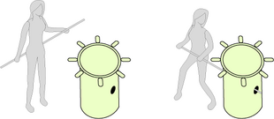](https://hell-and-back.fandom.com/wiki/File:Mockup_Interaction.png)

**Table of Metrics**

|  |  |
| --- | --- |
| **Detail** | **Specification** |
| Minimum distance for interacting | Players will have to be standing at a minimum of **50 uu** for interacting to be achievable. |

### Target Lock-on

**Overview**

This is about the ability auto locking /auto aiming at enemy if they’re within the universal radius and some abilities are not aiming some abilities you have to actually explicitly change the target otherwise it will auto lock on the TARGET priority. There is also hero locking where you see a HUD indicator of the player and if you click on it then all your attacks will be locked unto that player if you don’t change it

**Visualization**

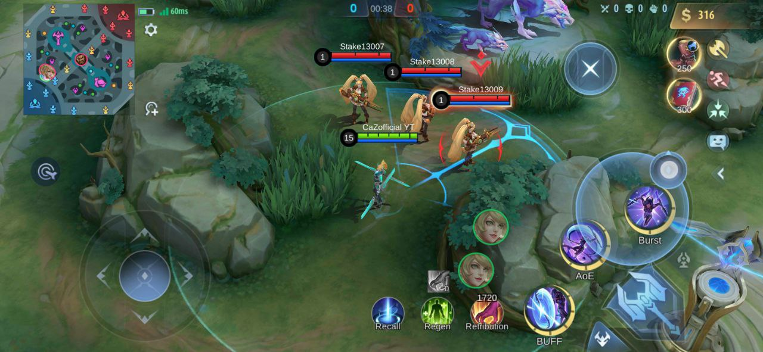

**Table of Metrics**

|  |  |
| --- | --- |
| **Detail** | **Specification** |
| Minimum distance for lock-on | Players must be in their respective range of attack for lock-on to be enabled. |
| Lock-on indicator | The lock-on will provide players feedback on which enemies they would hit if an attack is executed. |

### Abilities – Cooldown as well

[**https://mobile-legends.fandom.com/wiki/Crowd_control#Crowd_control_effects**](https://mobile-legends.fandom.com/wiki/Crowd_control#Crowd_control_effects)

[**https://leagueoflegends.fandom.com/wiki/Types_of_Crowd_Control**](https://leagueoflegends.fandom.com/wiki/Types_of_Crowd_Control)

[**https://leagueoflegends.fandom.com/wiki/Types_of_Crowd_Control_(Wild_Rift)**](https://leagueoflegends.fandom.com/wiki/Types_of_Crowd_Control_(Wild_Rift))

**Overview**

There are many abilities and they all fit into many types.

* AoE (Area of Effect) – wide area effect
* Burst Damage – massive damage
* Health - Next is the health type skill or means healer. ...
* Crowd Control / CC – Stun, silent, slow, suppressed, knock back
* Blink – mobility in the form of teleportation
* Buff – this increases stats of skills
* Speed Up – increases the mobility of a hero
* Morph – This is a CC that transform the opponent leaving them unable to do anything

Abilities may also have different effects such as the effects shown in the image below and abilities also have cooldowns which scale depending on the level of the ability and cooldown reductions from items

There are many things that go into an ability such as:

* Level – Ability 1 and 2 tend to have the same amount of level upgrades (6) and ability3 tends to have 3 because it is an ultimate and all the level always add up to 15
* Nazomeita Cost – Depending on the skill this can either stay the same or change in cost and this cost will change by default based on the ability level and then the player can buy item to further reduce this.
* Base Damage – this is the same as the nazomeita cost, it increases with level and the items can increase the base damage
* Destination damage is a skill specific thing only for this example hero and his skill
* They ability will also have its type, effect and purpose
  + E.g. the type is magic skill in this case this is for item effects such as magic lifesteal because it triggers magical lifesteal and not physical lifesteal
  + The effect is a slow effect
  + The purpose would be AoE and speed Up

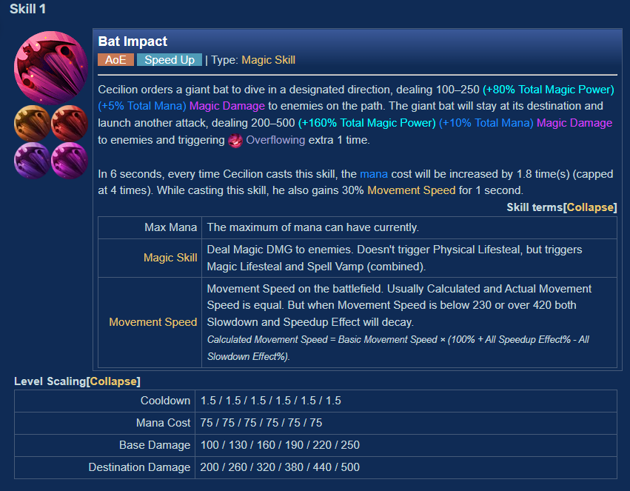

Also depending on the individual there may be things that come with the ability e.g.



<https://mobile-legends.fandom.com/wiki/Cecilion#Skill_1>

And there are things like perks that happen One personal example of this that when all AMP members are on a team they all get the AMP lightning perk which would have a positive effect on all of them individually.

Another example would be cecilion and Carmilla from mobile legends

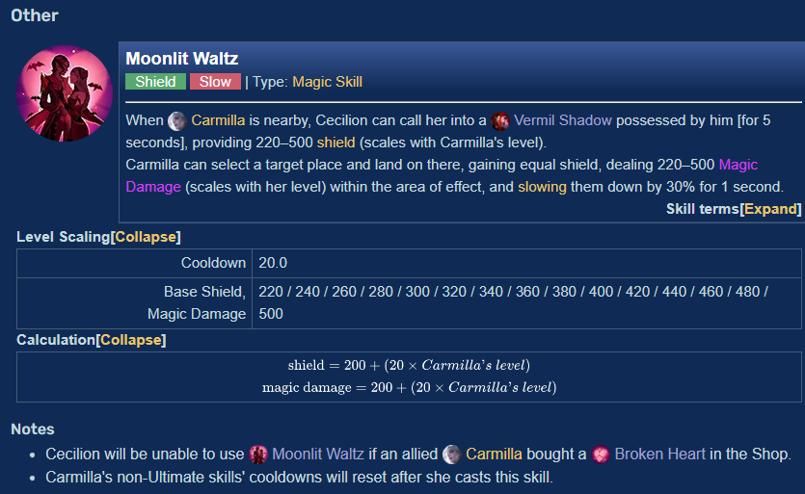

**Visualization**

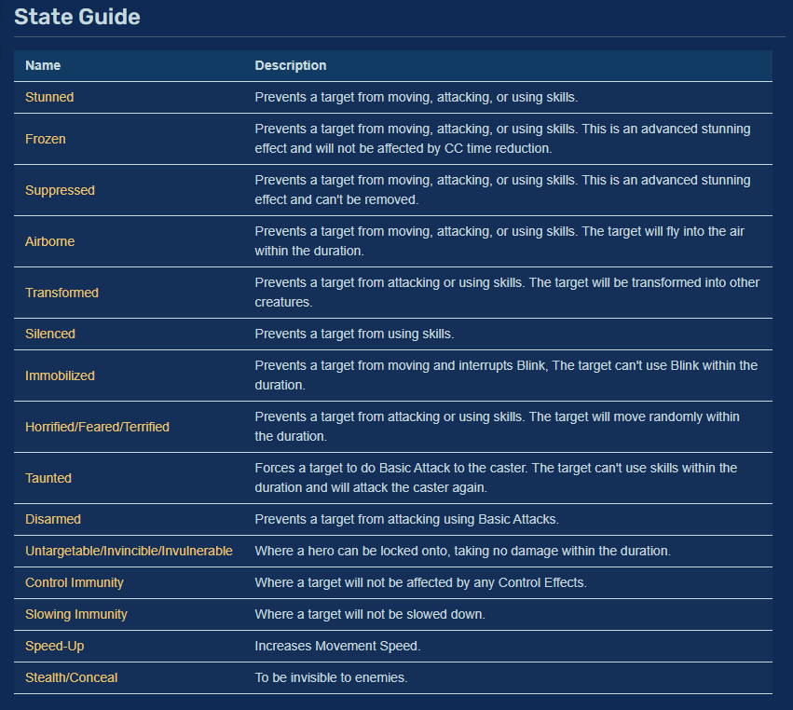

**Table of Metrics**

|  |  |  |  |  |  |  |
| --- | --- | --- | --- | --- | --- | --- |
| **Hero** | **Abilities** | **Ability effects** | **Cooldowns** | **Nazomeita Cost** | **Base Damage** | **HP Regen** |
|  |  |  |  |  |  |  |
|  |  |  |  |  |  |  |
|  |  |  |  |  |  |  |

Code

When you tap the ability the ability auto aims at the target it has prioritized by getting the direction but when you tap and hold the ability you a joystick appears and so does the cancel button

### GameManager

**Overview**

Not only will there be A game Manager there will be a Player manager. The game manager will handle stuff like kills, time management, Spawning, and what team has won.

The player manager would handle things in the setting that affect the player gameplay, it will also take into account the players KDA, hero’s locked target and etc.

There will also be a hero manager that will handle all the hero stuff which is specified in he hero stuff section

**Visualization**

**Table of Metrics for GameManager**

|  |  |
| --- | --- |
| **Variable** | **Specification** |
| M_Time Manager | Keeps track of time |
| M_Game is over | Checks whether game is over |

**Table of Metrics for PlayerManager**

|  |  |
| --- | --- |
| **Variable** | **Specification** |
| M_LockeHero | The hero the player has chosen to lock on |
| M_Kills (readOnly) | Keeps track of the players kills |
| M_VoiceLines | Has all the voice lines the hero has |

**Table of Metrics for HeroManager**

|  |  |
| --- | --- |
| **Variable** | **Specification** |
| Minimum distance for lock-on | Players must be in their respective range of attack for lock-on to be enabled. |
| Lock-on indicator | The lock-on will provide players feedback on which enemies they would hit if an attack is executed. |

### Animations

**Overview**

None of the animation will really use procedural animation or IK just blend animation for their movement and normal animations for their attacks and abilities, monsters will also have animations because when they spawn the have an animation and they also have attack animations and more

**Visualization**

[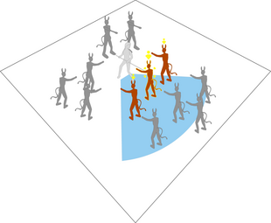](https://hell-and-back.fandom.com/wiki/File:Mockup_Lock_On.png)

**Table of Metrics**

|  |  |
| --- | --- |
| **Object type** | **Animations** |
| Hero | Movement blend, basic Attack, ability, death, recall |
| Monster | Spawn, attack, death, movement |
| Minions | Attack, death, movement |
| Great Monsters | Attack, Special attack, death, movement, spawn |

### UI

<https://unityassetsfreedom.club/download/moba-ui-kit-free-download/>

**Overview**

The UI is the in game UI, where the player can navigate through things that they want to do whether they want to buy stuff, to where they want to change their settings etc.

There can also

**Visualization**

Visualization is in GDD

Code

This will use the command pattern when clicking and going through different sections of the UI and pop up will be done with scriptableObjects and a prefab and will only be don’t once the player enters the game. There will also be a code that allows the player to quit by going back

### Ability Indicators

**Overview**

These are the things that show the direction of the ability, the range, the thickness and the even the type of ability it is and the radius it covers

**Visualization**



**Table of Metrics**

|  |  |
| --- | --- |
| **Indicator Type** | **Description** |
| Direction based | These are abilities that just point in on direction and their limit is the edge of the circle, they can be thin or thick |
| Aoe | These usually are a circle that is based on the area it does damage to |
| Arc | This is an arc that is expanding |

Code

Code for an arc

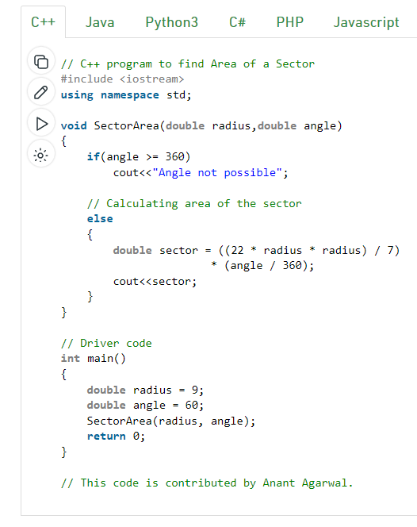

### Attacking and Targeting (This includes turret and monsters)

[**https://www.reddit.com/r/wildrift/comments/zb79gx/crits_explained/**](https://www.reddit.com/r/wildrift/comments/zb79gx/crits_explained/)

**Overview**

Due to

**Visualization**

[](https://hell-and-back.fandom.com/wiki/File:Mockup_Lock_On.png)

**Table of Metrics**

|  |  |
| --- | --- |
| **Detail** | **Specification** |
| Minimum distance for lock-on | Players must be in their respective range of attack for lock-on to be enabled. |
| Lock-on indicator | The lock-on will provide players feedback on which enemies they would hit if an attack is executed. |

Code

### Camera – Locking and Unlocking

**Overview**

The camera starts off locked and only becomes unlocked when the player touches the right side of the screen then when they do and drag the camera becomes unlocked and the sensitivity that is set in the settings is used. Then when you release it snaps back to locked and unto the player

**Visualization**

**Table of Metrics**

|  |  |
| --- | --- |
| **Detail** | **Specification** |
| Minimum distance for lock-on | Players must be in their respective range of attack for lock-on to be enabled. |
| Lock-on indicator | The lock-on will provide players feedback on which enemies they would hit if an attack is executed. |

### Health

[**https://leagueoflegends.fandom.com/wiki/Health_bar**](https://leagueoflegends.fandom.com/wiki/Health_bar)

[**https://mobile-legends.fandom.com/wiki/Shield**](https://mobile-legends.fandom.com/wiki/Shield)

**Overview**

There are 2 levelling ups in the game the player account and that is usually capped at level 30 but it can increase to past that on some MOBAs such as mobile legends who increased the level cap. The experience you gain is based on whether you win or lose a game, the game and your performance in the actual game and more things.

The other levelling up system is for the players in the game/ match the link above goes up to level 18 but the levl cap for my game will be level 15, there will also be things like share exp and assists

**Visualization**

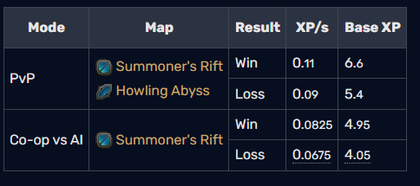

**Table of Metrics**

|  |  |
| --- | --- |
| **Detail** | **Specification** |
| Minimum distance for lock-on | Players must be in their respective range of attack for lock-on to be enabled. |
| Lock-on indicator | The lock-on will provide players feedback on which enemies they would hit if an attack is executed. |

### Levelling up and Exp

**Overview**

There are 2 levelling ups in the game the player account and that is usually capped at level 30 but it can increase to past that on some MOBAs such as mobile legends who increased the level cap. The experience you gain is based on whether you win or lose a game, the game and your performance in the actual game and more things.

<https://leagueoflegends.fandom.com/wiki/Experience_(summoner)>

<https://leagueoflegends.fandom.com/wiki/Experience_(champion)>

The other levelling up system is for the players in the game/ match the link above goes up to level 18 but the levl cap for my game will be level 15, there will also be things like share exp and assists

**Visualization**



**Table of Metrics**

|  |  |
| --- | --- |
| **Detail** | **Specification** |
| Minimum distance for lock-on | Players must be in their respective range of attack for lock-on to be enabled. |
| Lock-on indicator | The lock-on will provide players feedback on which enemies they would hit if an attack is executed. |

### Stats tracking

**Overview**

This is for the stats that are save for the account these are also hidden data categories that are tracked such as:

Rank – highest rank, current rank

Achievements

Match history

Matches – current season, all seasons

Win rates

MVPs – MVP Loses

Kills – Legendary(8 or more), quadra kills, Penta kills, Triple Kill, Double kill, Highest Kill ever, Highest Assists, Longest Win Streak, first blood, Highest Damage Per Min, Highest Damage Taken Per min, Highest Gold Per Min

Heroes – Matches, win rates

Credit Score

**Visualization**

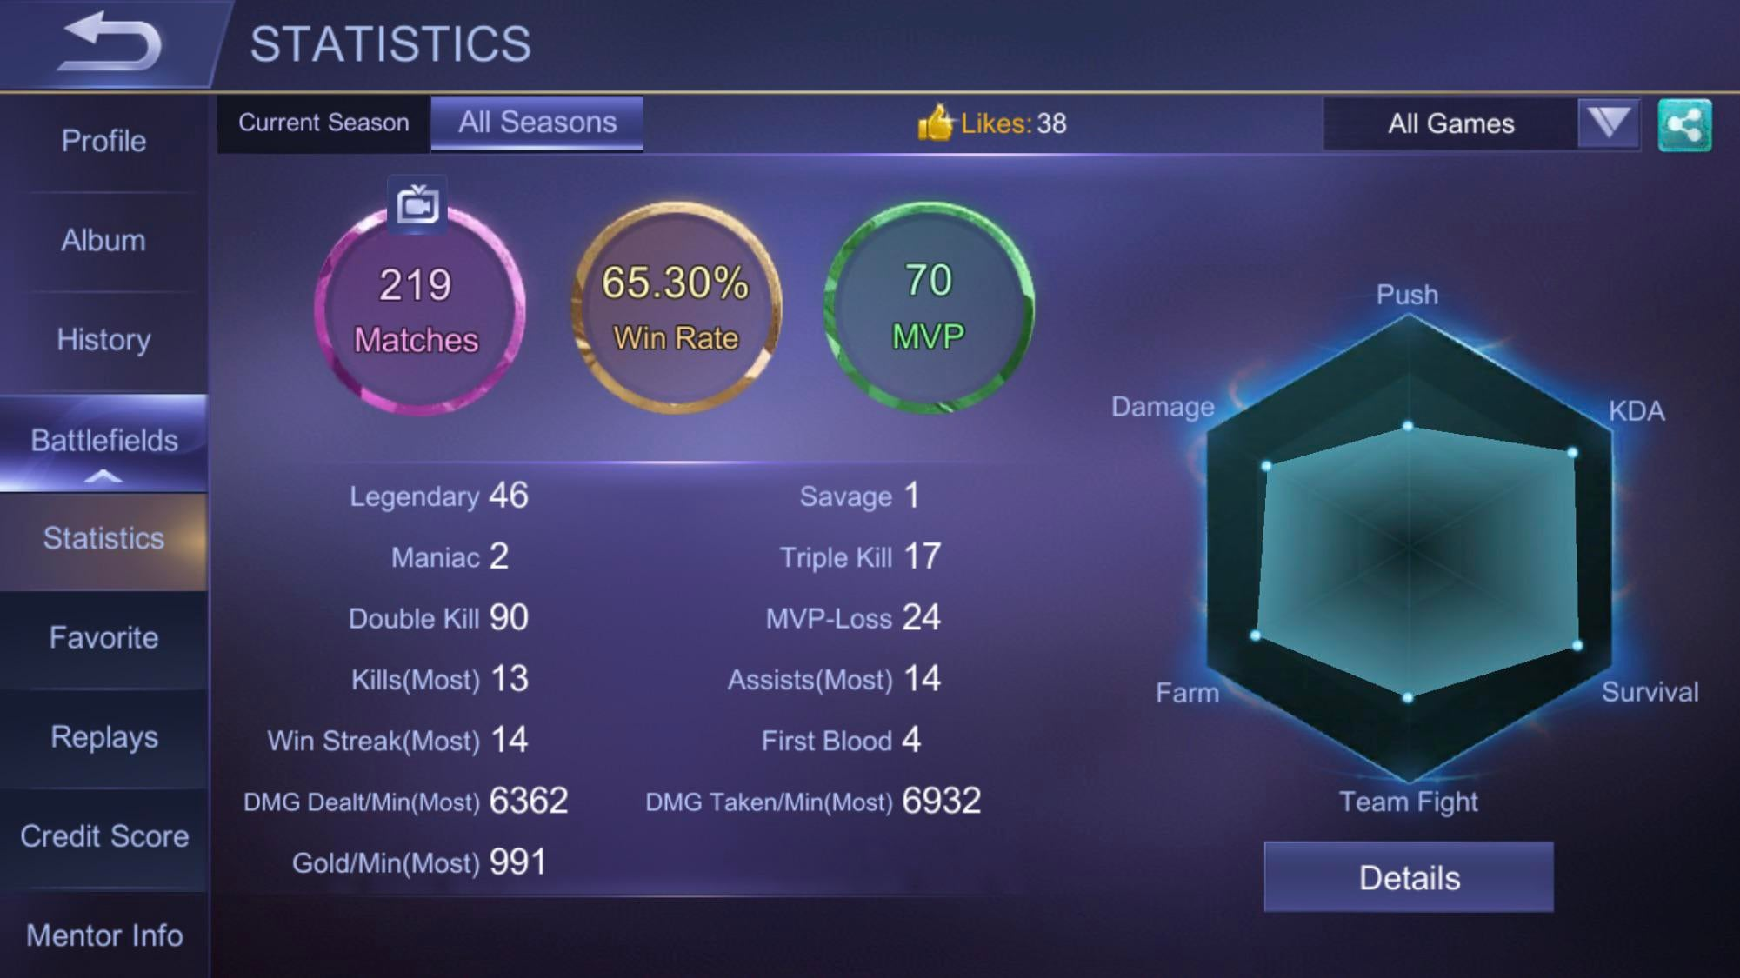

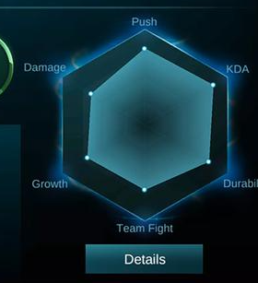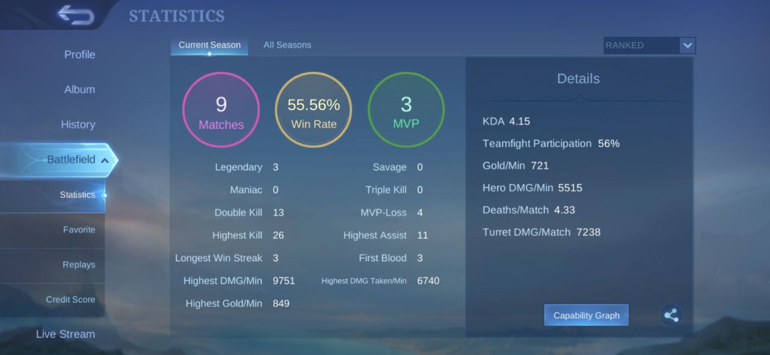

**Table of Metrics**

|  |  |
| --- | --- |
| **Detail** | **Specification** |
| Minimum distance for lock-on | Players must be in their respective range of attack for lock-on to be enabled. |
| Lock-on indicator | The lock-on will provide players feedback on which enemies they would hit if an attack is executed. |

### Battle spells

**Overview**

Battle Spells are the spells at the bottom of the screen these are the recall and regen and the third option is a chosen option which the player can decide and there are many versions

**Visualization**

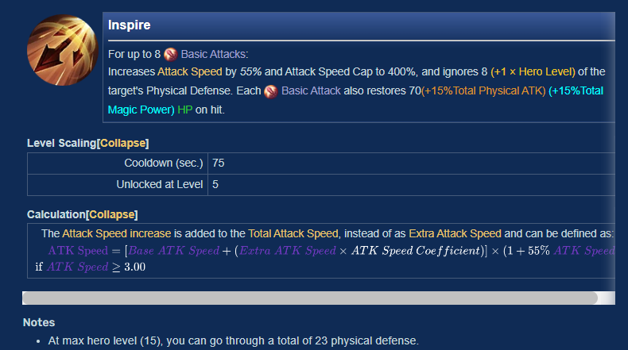

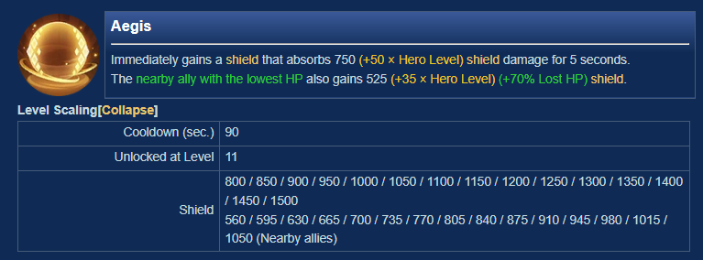

**Table of Metrics**

|  |  |  |
| --- | --- | --- |
| **Name** | **Description** | **Stats** |
|  |  |  |
|  |  |  |

## Stretch Goals

As stated before, our Stretch Goals mainly reside in creating a Tutorial at the beginning of the game as well as a Boss Fight at the very end. While creating a Tutorial is more Game Design challenging, the Boss Fight would require an extra effort for a creation of a unique *A.I.* for it to defer from the already built-in horde system for common enemies.

## Other Mechanics

### Account

**Overview**

This is the account that contains all the information about the player and contains the record and player ID and account email and stuff. When you create an account you select which side of the war you are on and there are events where you can only select the hero on your side of the war

**Visualization**

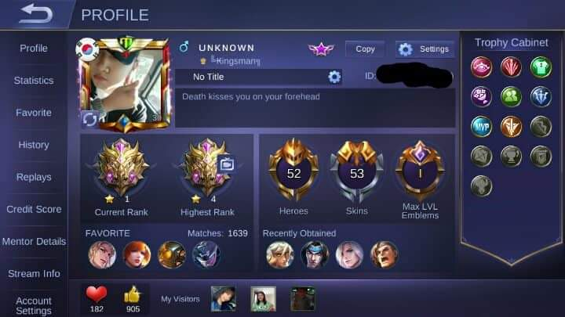

**Table of Metrics**

|  |  |
| --- | --- |
| **Detail** | **Specification** |
| Account name | Players must be in their respective range of attack for lock-on to be enabled. |
| Avatar |  |
| Account ID | The lock-on will provide players feedback on which enemies they would hit if an attack were executed. |
| Account Level |  |
| Location |  |
| Region |  |
| Matches Played |  |
| Heroes owned |  |
| Skins Owns |  |
| Match History |  |
| Achievement |  |
| Matches |  |
| Win Rates |  |
| MVP |  |
| Kills |  |
| Favourite |  |
| Credit Score |  |
| Email Address |  |

### Localization

[**https://phrase.com/blog/posts/localizing-unity-games-official-localization-package/**](https://phrase.com/blog/posts/localizing-unity-games-official-localization-package/)

**Overview**

This is the

**Visualization**



**Table of Metrics**

### Caps

**Overview**

These are the things that will be capped in the game such as money earned

**Visualization**



**Table of Metrics**

|  |  |
| --- | --- |
| **Detail** | **Specification** |
| Account name | Players must be in their respective range of attack for lock-on to be enabled. |
| Avatar |  |
| Account ID | The lock-on will provide players feedback on which enemies they would hit if an attack were executed. |
| Account Level |  |
| Location |  |
| Region |  |
| Matches Played |  |
| Heroes owned |  |
| Skins Owns |  |
| Match History |  |
| Achievement |  |
| Matches |  |
| Win Rates |  |
| MVP |  |
| Kills |  |
| Favourite |  |
| Credit Score |  |
| Email Address |  |

### Settings

**Overview**

Most of the settings are used to affect gameplay and very few affect things outside of gameplay but over the other iteration there will be many more things added to it.

**Visualization**

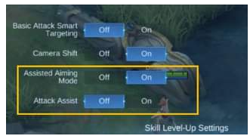

**Table of Metrics**

|  |  |
| --- | --- |
| **Detail** | **Specification** |
| Camera Height | High or Low |
| Screen Shake | Off or On |
| Shadow | On or Off |
| Damage Text | Off or On |
| Graphics | Low, medium and high |
| Controls | Standard, Advanced and Maybe (Additional) |
| Target Priority | Lowest HP, Lowest HP, Closest Target |
| Main Volume | On or off |
| Music | Low to High |
| Sound Effects | Low to high |
| Hero Voice(maybe) | Low to High |

Code

Have a settings class and in the settings class, it should have these things as variables and some as bool and some as enums

### Effects

These are Things like coin effects after you kill a minion

<https://leagueoflegends.fandom.com/wiki/Assist>

**Overview**

Due

**Visualization**

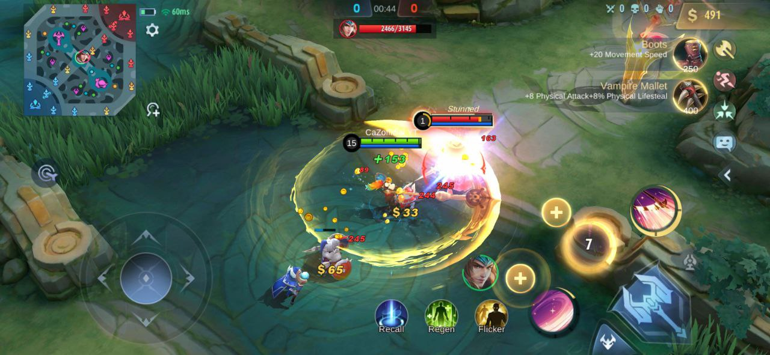

**Table of Metrics**

|  |  |
| --- | --- |
| **Detail** | **Specification** |
| Gold | Yellow |
| damage | Red |

Code

This will be done using the dotween effect

### States

These are Things like coin effects after you kill a minion

[*https://mobile-legends.fandom.com/wiki/Immobilized*](https://mobile-legends.fandom.com/wiki/Immobilized)

[*https://mobile-legends.fandom.com/wiki/Stunned#:~:text=Stunned%20or%20stun%20effect%20is,up%20to%202%20whole%20seconds*](https://mobile-legends.fandom.com/wiki/Stunned#:~:text=Stunned%20or%20stun%20effect%20is,up%20to%202%20whole%20seconds)*.*

[*https://mobile-legends.fandom.com/wiki/Knocked_back*](https://mobile-legends.fandom.com/wiki/Knocked_back)

[*https://mobile-legends.fandom.com/wiki/Transformed*](https://mobile-legends.fandom.com/wiki/Transformed)

[*https://mobile-legends.fandom.com/wiki/Airborne*](https://mobile-legends.fandom.com/wiki/Airborne)

**Overview**

Due

**Visualization**



**Table of Metrics**

|  |  |
| --- | --- |
| **Detail** | **Specification** |
| Gold | Yellow |
| damage | Red |

Code

This will be done using the dotween effect

### Death Respawn Time

<https://leagueoflegends.fandom.com/wiki/Death>

this is the calculation for it

**Overview**

The death respawn time is an important part of the game this is because over time as the game goes on the timer increases and get very long and this is to avoid the game from going on forever.

**Base re-spawn time** (BRW)

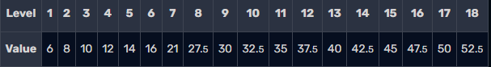

**Visualization**

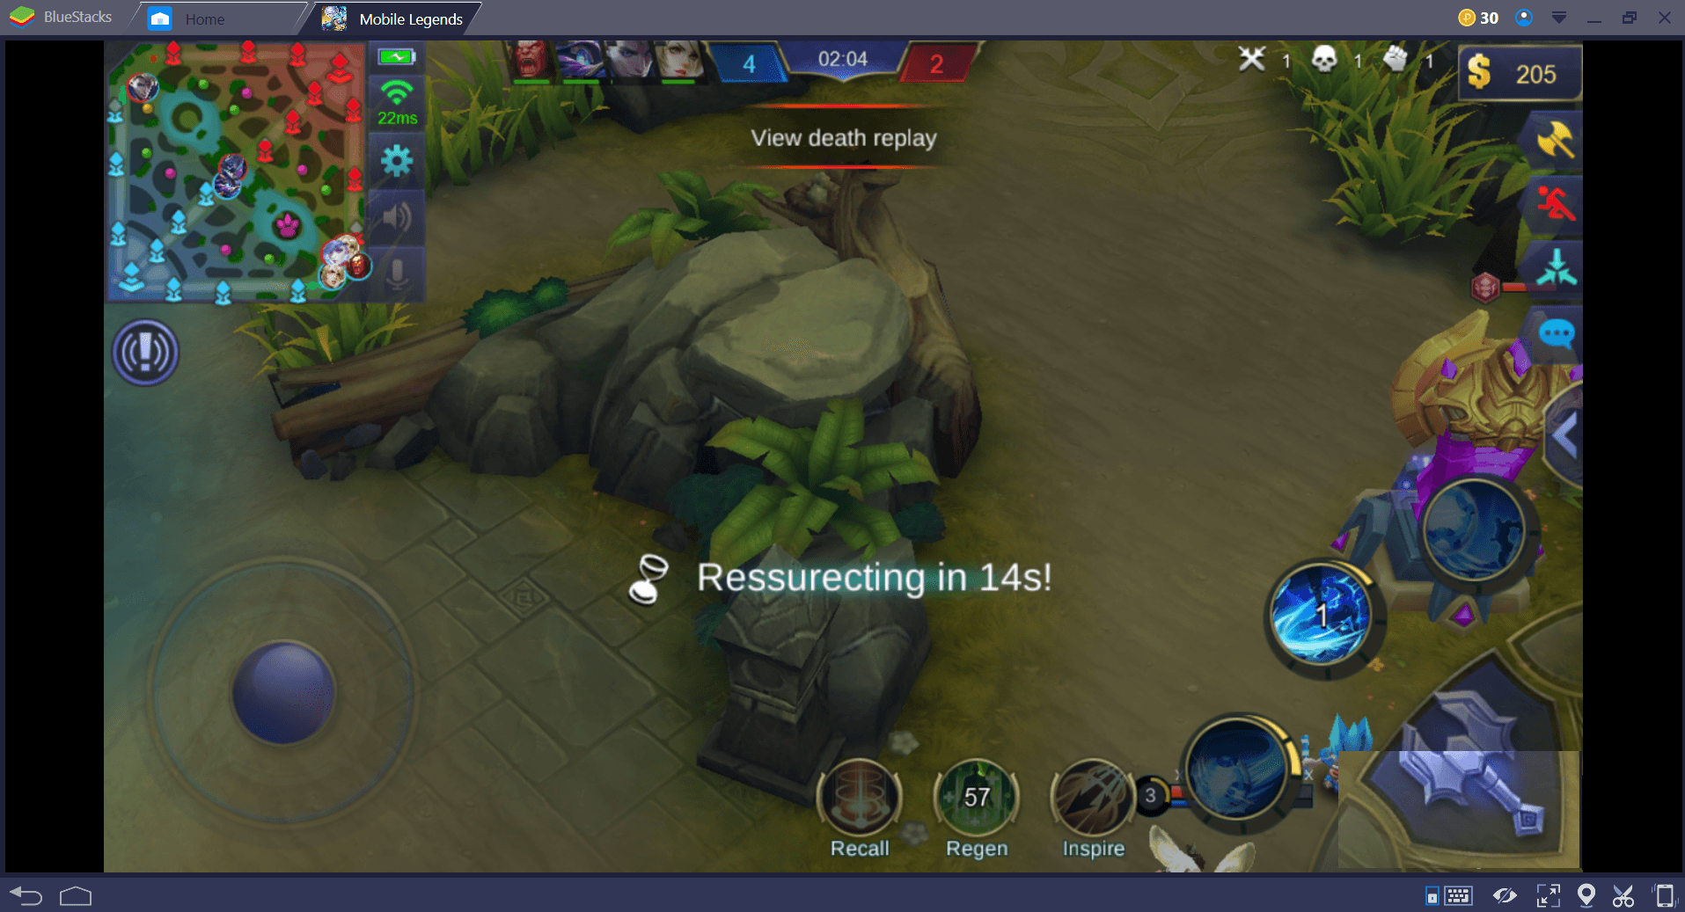

**Table of Metrics**

|  |  |
| --- | --- |
| **Detail** | **Specification** |
| Minimum distance for lock-on | Players must be in their respective range of attack for lock-on to be enabled. |
| Lock-on indicator | The lock-on will provide players feedback on which enemies they would hit if an attack is executed. |

### Damage taken

<https://mobile-legends.fandom.com/wiki/User_blog:Chrodotme/The_Complete_Damage_Calculation_Formula>

<https://mobile-legends.fandom.com/wiki/Physical_damage>

<https://mobile-legends.fandom.com/wiki/Damage>

<https://mobile-legends.fandom.com/wiki/Physical_defense>

<https://www.reddit.com/r/MobileLegendsGame/comments/k56369/whats_the_point_of_some_physical_heroes_scaling/>

<https://www.reddit.com/r/MobileLegendsGame/comments/k56369/whats_the_point_of_some_physical_heroes_scaling/>

<https://mobile-legends.fandom.com/wiki/Damage#Damage_types>

**Overview**

Damage taken takes in a lot of factors such as penetration, defense, armour, attack type and resistance and this needs to be calculated in order to take a sufficient amount of health from the player

**Visualization**

**Table of Metrics**

|  |  |
| --- | --- |
| **Detail** | **Specification** |
| Minimum distance for lock-on | Players must be in their respective range of attack for lock-on to be enabled. |
| Lock-on indicator | The lock-on will provide players feedback on which enemies they would hit if an attack is executed. |

### Menu Navigation

**Overview**

Menu navigation is how the player can go from one section of the entire menu to another then to another then to another and then still be able to go back in the reverse order they came in. An example of this is event, subscriptions and In-App Purchases

**Visualization**

**Table of Metrics**

|  |  |
| --- | --- |
| **Detail** | **Specification** |
| Minimum distance for lock-on | Players must be in their respective range of attack for lock-on to be enabled. |
| Lock-on indicator | The lock-on will provide players feedback on which enemies they would hit if an attack is executed. |

Code

This will use the command pattern and when there’s nothing else to go back to that’s when the option of quitting is presented.

<https://forum.unity.com/threads/unity-ui-flowchart.283423/>

<https://stackoverflow.com/questions/17593101/how-to-write-a-gui-editor-for-graph-or-tree-structures>

<https://en.m.wikipedia.org/wiki/Node_graph_architecture>

<https://forum.unity.com/threads/simple-node-editor.189230/>

[Video Tutorials - Pixel Crushers](https://www.pixelcrushers.com/dialogue-system/dialogue-system-tutorials/)

I could also use software behaviour tree

### Experience and Levelling system

**Overview**

Menu navigation is how the player can go from one section to another then to another then to another and then still be able to go bac in the reverse order they came in

**Visualization**

**Table of Metrics**

|  |  |
| --- | --- |
| **Detail** | **Specification** |
| Minimum distance for lock-on | Players must be in their respective range of attack for lock-on to be enabled. |
| Lock-on indicator | The lock-on will provide players feedback on which enemies they would hit if an attack is executed. |

Code

This will use the command pattern and when theres nothing else to go back to that’s when the option of quitting is presented.

### In-Match Inventory and shop system

Battle spells, builds, emblem etc. Basically the preparation section in Mobile legends

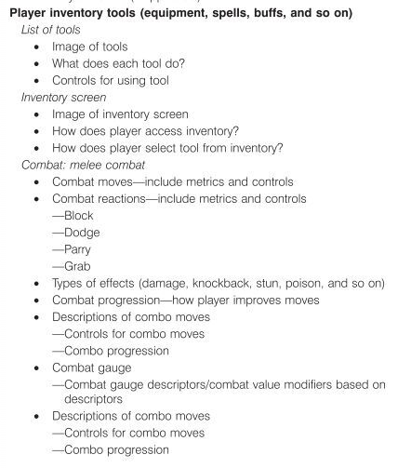

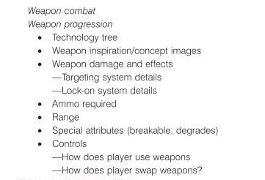

**Overview**

Due to the several number of enemies surrounding the players when in combat, they will be able to use a lock-on mechanic for them to be able to choose their desired enemy to engage. When locked-on, players will be assisted to land their attack on the desired target.

**Visualization**

[](https://hell-and-back.fandom.com/wiki/File:Mockup_Lock_On.png)

**Table of Metrics**

|  |  |
| --- | --- |
| **Detail** | **Specification** |
| Minimum distance for lock-on | Players must be in their respective range of attack for lock-on to be enabled. |
| Lock-on indicator | The lock-on will provide players feedback on which enemies they would hit if an attack is executed. |

### In-Match UI

Ping, Battery, etc.

**Overview**

Due to the several number of enemies surrounding the players when in combat, they will be able to use a lock-on mechanic for them to be able to choose their desired enemy to engage. When locked-on, players will be assisted to land their attack on the desired target.

**Visualization**

[](https://hell-and-back.fandom.com/wiki/File:Mockup_Lock_On.png)

**Table of Metrics**

|  |  |
| --- | --- |
| **Detail** | **Specification** |
| Minimum distance for lock-on | Players must be in their respective range of attack for lock-on to be enabled. |
| Lock-on indicator | The lock-on will provide players feedback on which enemies they would hit if an attack is executed. |

### Monsters

<https://mobile-legends.fandom.com/wiki/Lord>

### Hero stuff

<https://forum.unity.com/threads/tutorial-character-stats-aka-attributes-system.504095/>

<https://mobile-legends.fandom.com/wiki/Terminology>

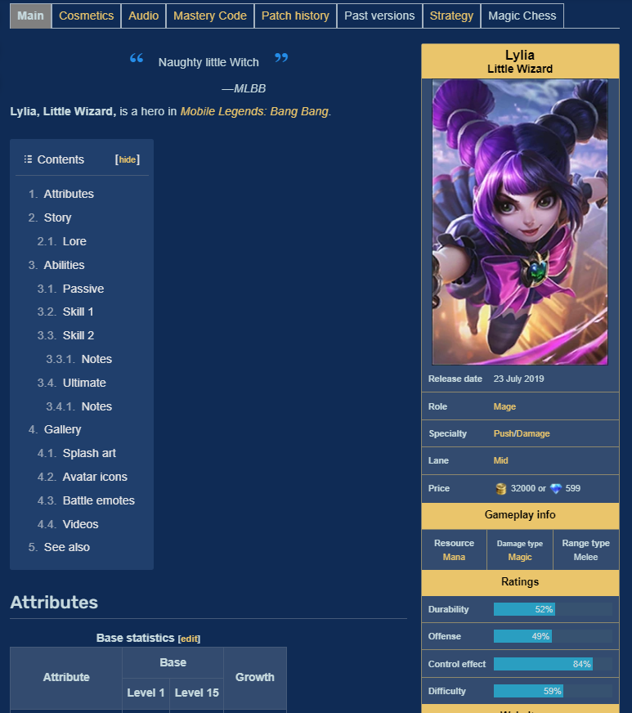

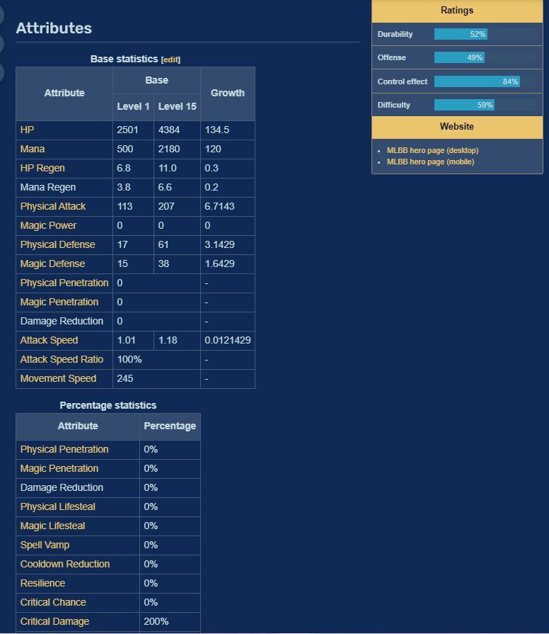

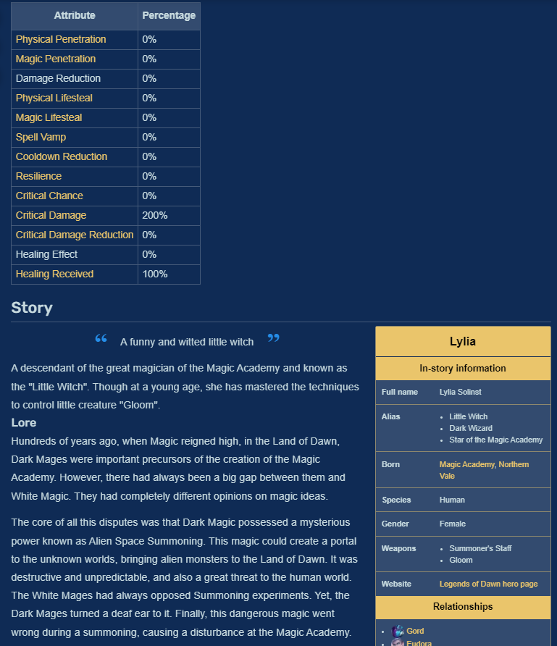

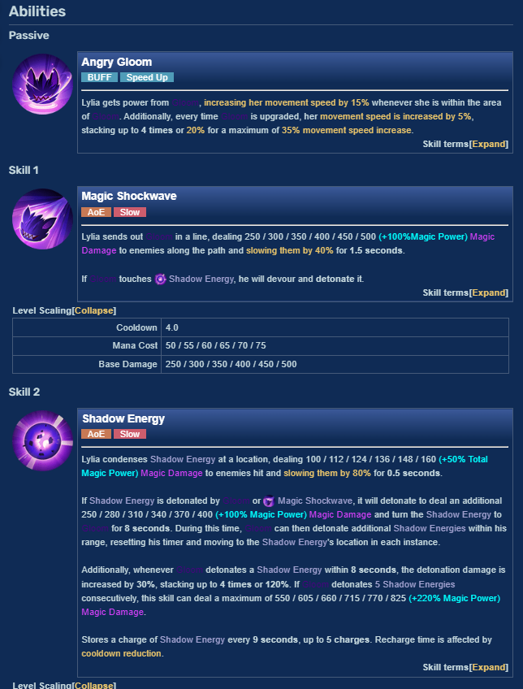

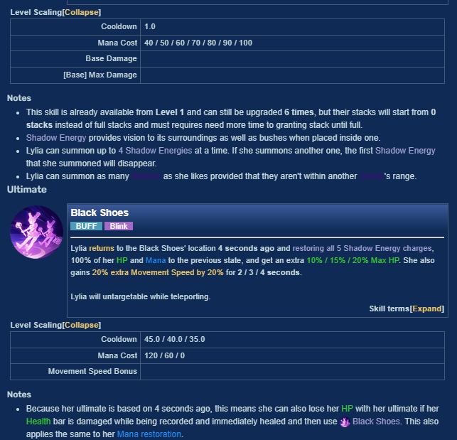

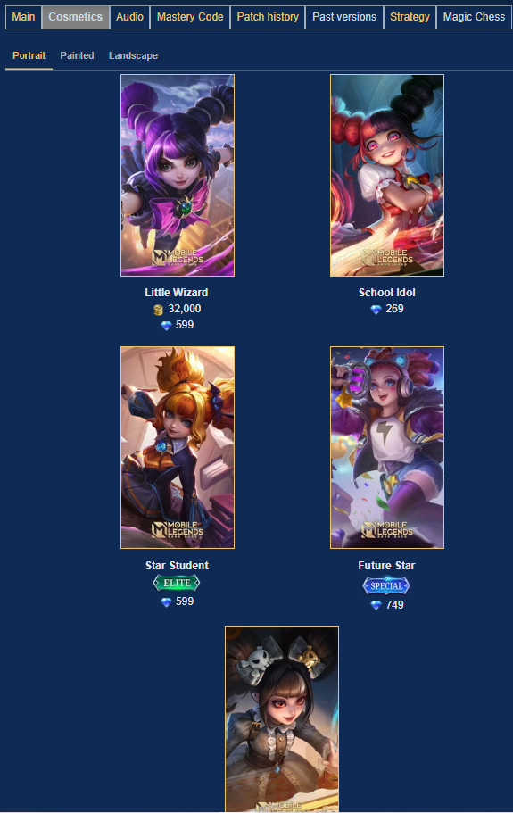

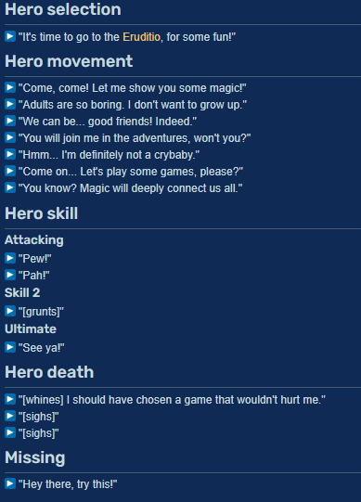

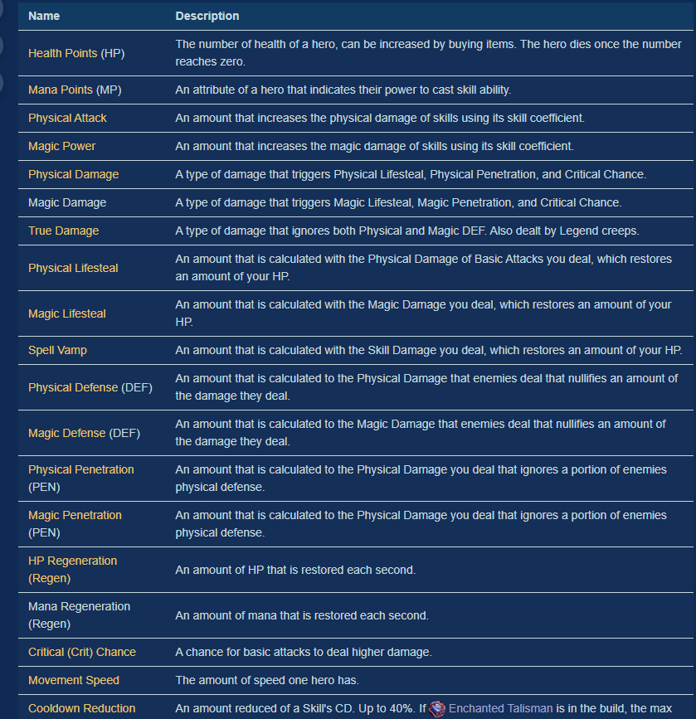

**Overview**

Due to the several number of enemies surrounding the players when in combat, they will be able to use a lock-on mechanic for them to be able to choose their desired enemy to engage. When locked-on, players will be assisted to land their attack on the desired target.

**Visualization**

[](https://hell-and-back.fandom.com/wiki/File:Mockup_Lock_On.png)

**Table of Metrics**

|  |  |
| --- | --- |
| **Detail** | **Specification** |
| Minimum distance for lock-on | Players must be in their respective range of attack for lock-on to be enabled. |
| Lock-on indicator | The lock-on will provide players feedback on which enemies they would hit if an attack is executed. |

# Off the shelf Tools

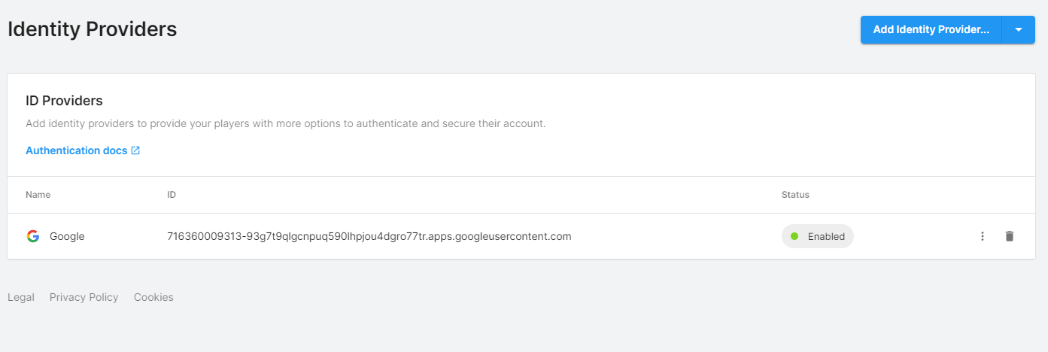

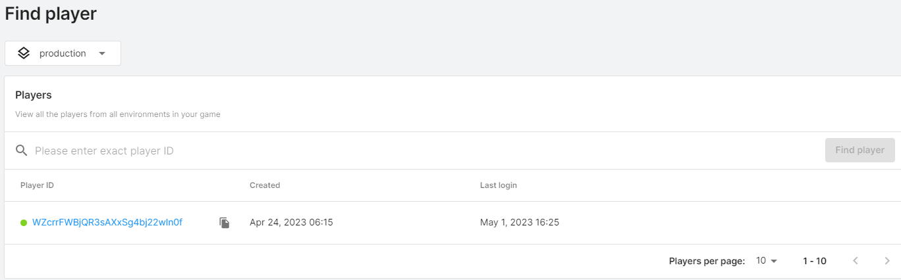

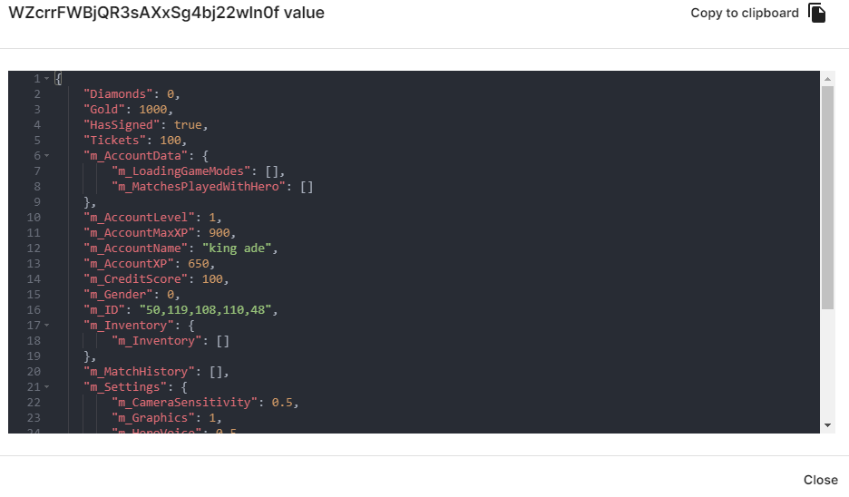

Screenshot of unity live operation Dashboard

**Link To Tools Page (WIP)** : <https://dashboard.unity3d.com/gaming/organizations/5772733725008/projects/a6f7964c-1224-4c73-b979-9c1befe1a4c9/environments/c81ec0f4-3ba1-464d-933e-749faf653252/economy/about>

The following are tools that will be used for our game:

**Cloud Content Delivery** : To keep players engaged for a long time, The live game needs to be updated with fresh content on a regular basis, however issues may arises when trying to maintain a consistent pipeline of new content but with this the technical infrastructure has been built which has a reliable content delivery network, Cloud Storage and asset management to send new content.

//ref - <https://unity.com/products/cloud-content-delivery>

**Live Data Manipulation:** With unity remote config I can fine tune the game without requiring a new deployment, You set up key value pairs in the cloud which the game then reads and utilizes allowin you to alter stats and other data at runtime and also works with text with allows for localization and conditional overrides

// ref - <https://unity.com/products/remote-config>

**Cloud Analytics Tool :** This allows a better understanding of players by allowing you to track, monitor and analyse player behaviour, it allows insights through dashboards and visualizations powered by realtime data. This tool also has robust data segmentation, the ability to query across the portfolio and high level flexibility. Every action a player takes within a game is recorded and stored

//ref - <https://unity.com/products/unity-analytics>

# Characters

<https://mobile-legends.fandom.com/wiki/Cecilion>

Character data this contains the data for each valorian in the game and the data for the equipments as well, which contains the tree for the equipment. There are many things and data that a character will have and will be different across all characters such as base attack speed, growth rate and many different stats that affect gameplay. There is also different lore for each character, different skills/ability as a character can have 3 abilities/skills where the skill may have very unique feature such as bas damage and destination damage, slowing effect, possession effect etc. There are also things such as cosmetics, strategy, audio and triggers for audio as there are many different characters have different triggers for their lines for example a valorian could say a line when their attack lands or misses or when they launch their attack etc. These are also the data the player will be able to see to help them decide their battle technique and strategy for their games.



# Cosmetics

This includes things in the game such as avatar borders. Cosmetics are assets the player can buy for either a valorian that is owned or to customise their account, examples of this are avatars, avatar borders, valorian audio, valorian statue etc.

# Technical Diagrams (UML)

## Class Diagrams

[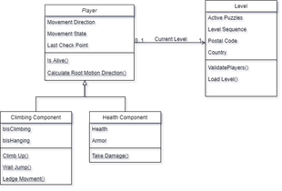](https://hell-and-back.fandom.com/wiki/File:A7.png)

Player Class Diagram

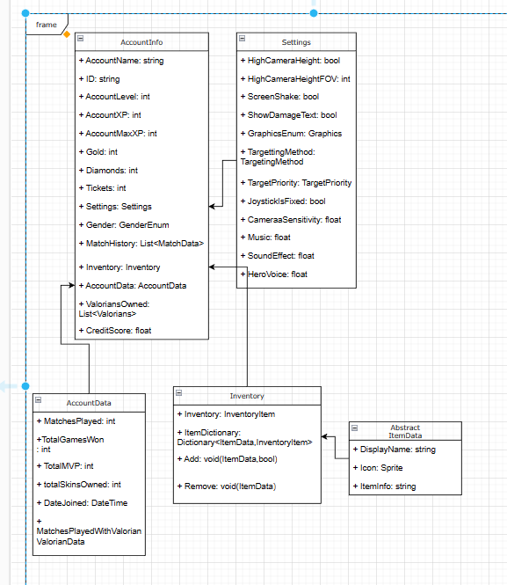

AccountInfo

## A.I. AFK System Behaviour Tree

The following behaviour tree diagrams describe in a rough manner the way our A.I. will behave when the player has been said to be AFK.

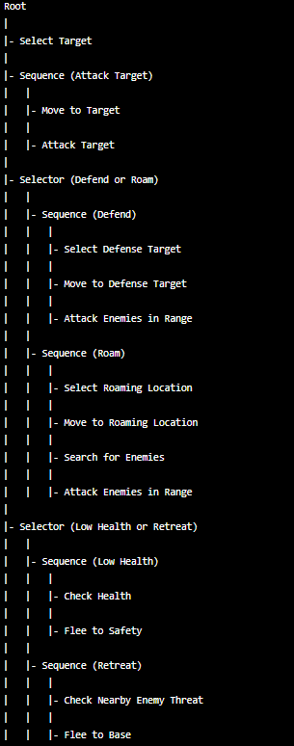

The behavior tree starts with the root node, which contains several child nodes that determine the AI character's behavior.

The first node is "Select Target," which selects an enemy target for the AI character to attack.

The second node is a "Sequence" node for attacking the selected target. The AI character will move towards the target and attack it as soon as it's within range.

The third node is a "Selector" node that determines whether the AI character should defend or roam. If there is a nearby defensive target, the AI character will prioritize defending. Otherwise, it will start roaming.

If the AI character's health is low, the behavior tree will select a "Low Health" sequence, which checks the character's health and then flees to safety. If there are nearby enemies, the behavior tree will select a "Retreat" sequence, which checks for nearby enemy threats and then flees to the base.

Overall, this behavior tree provides a basic set of behaviors for an AI character in a mobile MOBA, allowing it to move, attack, defend, roam, and retreat as needed.

# UI/UX

## Flow Charts/ State Diagram

[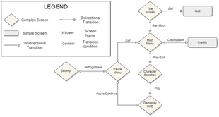](https://hell-and-back.fandom.com/wiki/File:A9.png)

UI Screens Flowchart

# Test Plan

Our game requires a lot of playtesting due to the game’s genre. Therefore, tests shall be done consistently throughout the development of the game.

1. Gameplay testing
   * Verify that the game mechanics work as intended.
   * Verify that all abilities of each character work as intended.
   * Verify that all objectives (towers, minions, etc.) can be interacted with properly.
2. User Interface (UI) testing
   * Verify that the UI elements are displayed correctly on different devices with different screen sizes.
   * Verify that the UI is user-friendly and intuitive.
   * Verify that all buttons, menus, and settings work as intended.
3. Network testing
   * Verify that the game works smoothly without lag or disconnections.
   * Verify that the matchmaking system works as intended.
   * Verify that the game supports different connection speeds and types.
4. Performance testing
   * Verify that the game runs smoothly on different devices with different specifications.
   * Verify that the game does not overheat or drain the battery excessively.
   * Verify that the game's performance does not degrade over time.
5. Compatibility testing
   * Verify that the game is compatible with different versions of mobile operating systems.
   * Verify that the game is compatible with different models of mobile devices.
   * Verify that the game is compatible with different types of hardware (processors, graphics cards, etc.)
6. Security testing
   * Verify that the game does not contain any malware or viruses.
   * Verify that the game's data is encrypted and protected from unauthorized access.
   * Verify that the game's payment system (if any) is secure and free from fraud.
7. Localization testing
   * Verify that the game's text and audio are correctly translated into different languages.
   * Verify that the game's content is appropriate for different cultures and regions.
   * Verify that the game's UI can be adapted to different languages and scripts.
8. Regression testing
   * Verify that all issues identified during testing have been resolved in subsequent releases.
   * Verify that new releases do not introduce new issues or regressions.
   * Verify that the game works as intended after new features have been added or existing features have been modified.

## Types of tests

**Player Combat and Control test**

Players must feel the movement and combat according to our games pillars. This is the most important test of all, as it will differ if our game is actually enjoyable.

**Character DPS**

The game will challenge the player’s skill heavily through combat. Therefore, Character DPS testing shall be done to improve the game’s combat and balancing.

**AI Behaviors**

The game’s A.I. is a feature on its own and shall be treated as such. The A.I. must be stress-tested to show it’s true capabilities in early stages of the game to prove our goals.

**Networking Replication Test**

For the online feature of the game to be fully implemented and working in game, network replication must be tested each time a new feature and/or mechanic is implemented in game in order to prevent lack or a tackle on the game’s experience.

**Progress Tracking**

For the small experience to be actually playable from beginning to end in the given 10-15 minute window at *Pitch & Play*, we must have our players’ progress tracked and tested to optimize the experience at the highest quality possible.

# Test Cadence

|  |  |
| --- | --- |
| **Test** | **Cadence** |
| Player Combat and Control | Manually, once per week. |
| Character DPS | Manually, once per 10 days. |
| AI Behaviors | Manually, once per end of the week. |
| Networking Replication Test | Manually, every time a new feature or mechanic is introduced in-engine. |
| Progress Tracking | Manually, once per end of the week. |

# Test Schedule

|  |  |  |
| --- | --- | --- |
| **Milestone** | **Day** | **Playtest Focus** |
| **M1** | 2020/05/09 | Movement Feeling |
| 2020/05/15 | Combat Feeling |
| 2020/05/20 | Full Combat Encounter |
| **M2** | 2020/05/30 | Full Combat Encounter - Polished |
| 2020/06/03 | Main Level A |
| 2020/06/04 | Main Level B |
| **M3** | 2020/06/17 | Full gameplay - rough test |
| 2020/06/22 | Full gameplay - polish |
| 2020/06/26 | Blind Playtest |
| **ALPHA** | 2020/07/06 | Blind Playtest 1 |
| 2020/07/13 | Blind Playtest 2 |
| 2020/07/15 | Blind Playtest 3 |
| **BETA** | 2020/07/21 | Blind Playtest 1 |
| 2020/07/27 | Blind Playtest 2 |
| 2020/07/29 | Blind Playtest 3 |
| **FINAL** | 2020/08/03 | FINAL Playtest 1 |
| 2020/08/04 | FINAL Playtest 2 |
| 2020/08/05 | FINAL Playtest 3 |

# Technical Risks

The following are the major Tech Risks that we identified during Prototyping and Pre-Production along with their contingency plans:

|  |  |  |  |  |
| --- | --- | --- | --- | --- |
| ***Risk*** | ***Impact*** | ***Probability*** | ***Mitigation Plan*** | ***Contingency Plan*** |
| *If the minimum in house tools are not developed by****M1****then our game will be affected in Level Design.* | **HIGH** | MED | Have the core tools developed during the first month of Production in at least a rough first draft. | Cut the Boss Fight to prevent it from dragging both Level Design and Programming sides for the core development of the game. |
| *If Networking is not fully implemented with as less lag as possible by the end****M2****then we will lose our online feature.* | **HIGH** | MED | Constantly work on *Networking* from Pre-Production stages testing different aspects like animation replication. | Remove the online feature from our game and have it deployed only on a LAN network. |

[**https://mobile-legends.fandom.com/wiki**](https://mobile-legends.fandom.com/wiki)

<https://media.bloomsbury.com/rep/files/gdd_template.pdf>

<https://www.reddit.com/r/gamedesign/comments/pc9yma/what_are_the_fundamentals_of_moba_item_design/>

<https://www.researchgate.net/publication/312617745_Fairness_Mechanism_in_Multiplayer_Online_Battle_Arena_Games>

<https://www.ubishops.ca/wp-content/uploads/huang20180425.pdf>

<https://homepages.dcc.ufmg.br/~chaimo/public/EntertainmentComputing17.pdf>

<https://www.youtube.com/watch?v=tR-9oXiytsk>

<https://www.reddit.com/r/heroesofthestorm/comments/ab2rw4/how_are_you_supposed_to_balance_a_moba/>

<https://forum.unity.com/threads/balancing-a-moba-or-rpg-game.289306/>

<https://www.diva-portal.org/smash/get/diva2:818292/FULLTEXT01.pdf>

Workflow

This is what I’m going to start doing, then what I will do next in order and how

e.g. Movement, abilities, animations etc.

First the in-match stuff (not in this order)

Movement, camera, abilities, perks, GameManager, a.i. spawning, sounds, health, dmg/health popups, recall, regen,

Movement

For the

Localization

<https://www.youtube.com/watch?v=YTMWMFIyQFM> – 21:30, <https://www.youtube.com/watch?v=MaFpf3nmHmo> – in more detail